TRY HACK ME: Wireshark: Traffic Analysis Write-Up (Part -1)



**Task 1 Introduction-**

In this room, we will cover the techniques and key points of traffic analysis with Wireshark and detect suspicious activities. Note that this is the third and last room of the Wireshark room trio, and it is suggested to visit the first two rooms stated below to practice and refresh your Wireshark skills before starting this one.

[Wireshark: The Basics](https://tryhackme.com/room/wiresharkthebasics)

[Wireshark: Packet Operations](https://tryhackme.com/room/wiresharkpacketoperations)

In the first two rooms, we have covered how to use Wireshark and do packet-level searches. Now, it is time to investigate and correlate the packet-level information to see the big picture in the network traffic, like detecting anomalies and malicious activities. For a security analyst, it is vital to stop and understand pieces of information spread in packets by applying the analyst's knowledge and tool functionality. This room will cover investigating packet-level details by synthesising the analyst knowledge and Wireshark functionality for detecting anomalies and odd situations for a given case.

**Note:** A VM is attached to this room. You don't need SSH or RDP; the room provides a "Split View" feature. DO NOT directly interact with any domains and IP addresses in this room. The domains and IP addresses are included only for reference reasons.

**Answer to the questions of this section-**

No Answer Needed

**Task 2 Nmap Scans –**

**Nmap Scans**

Nmap is an industry-standard tool for mapping networks, identifying live hosts and discovering the services. As it is one of the most used network scanner tools, a security analyst should identify the network patterns created with it. This section will cover identifying the most common Nmap scan types.

* TCP connect scans
* SYN scans
* UDP scans

It is essential to know how Nmap scans work to spot scan activity on the network. However, it is impossible to understand the scan details without using the correct filters. Below are the base filters to probe Nmap scan behaviour on the network.

TCP flags in a nutshell.

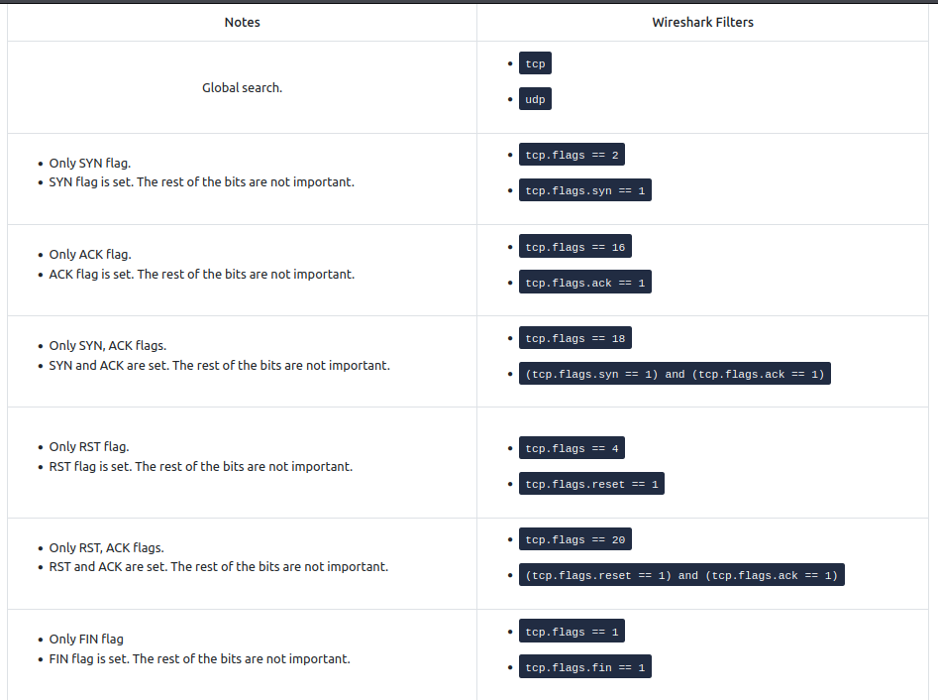

**TCP Connect Scans**

TCP Connect Scan in a nutshell:

* Relies on the three-way handshake (needs to finish the handshake process).
* Usually conducted with nmap -sT command.
* Used by non-privileged users (only option for a non-root user).
* Usually has a windows size larger than 1024 bytes as the request expects some data due to the nature of the protocol.

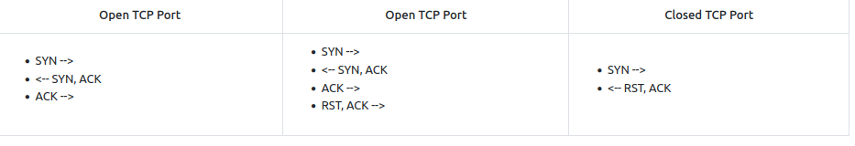

The images below show the three-way handshake process of the open and close TCP ports. Images and pcap samples are split to make the investigation easier and understand each case's details.

**Open TCP port (Connect):**

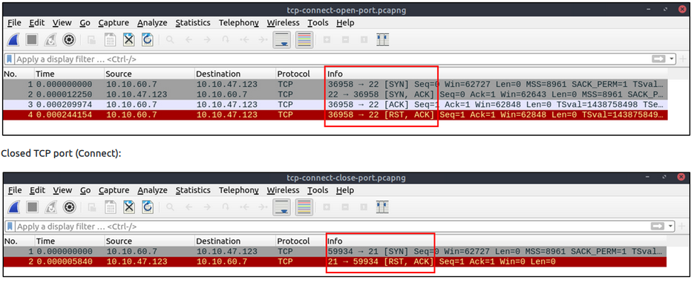

The above images provide the patterns in isolated traffic. However, it is not always easy to spot the given patterns in big capture files. Therefore analysts need to use a generic filter to view the initial anomaly patterns, and then it will be easier to focus on a specific traffic point. The given filter shows the TCP Connect scan patterns in a capture file.

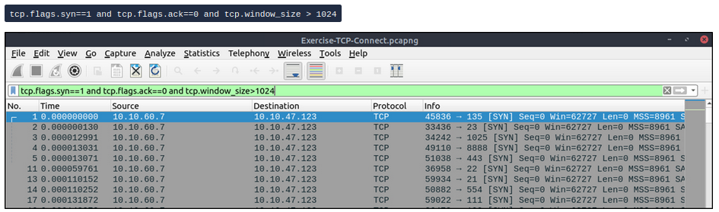

**SYN Scans**

TCP SYN Scan in a nutshell:

* Doesn't rely on the three-way handshake (no need to finish the handshake process).
* Usually conducted with nmap -sS command.
* Used by privileged users.
* Usually have a size less than or equal to 1024 bytes as the request is not finished and it doesn't expect to receive data.

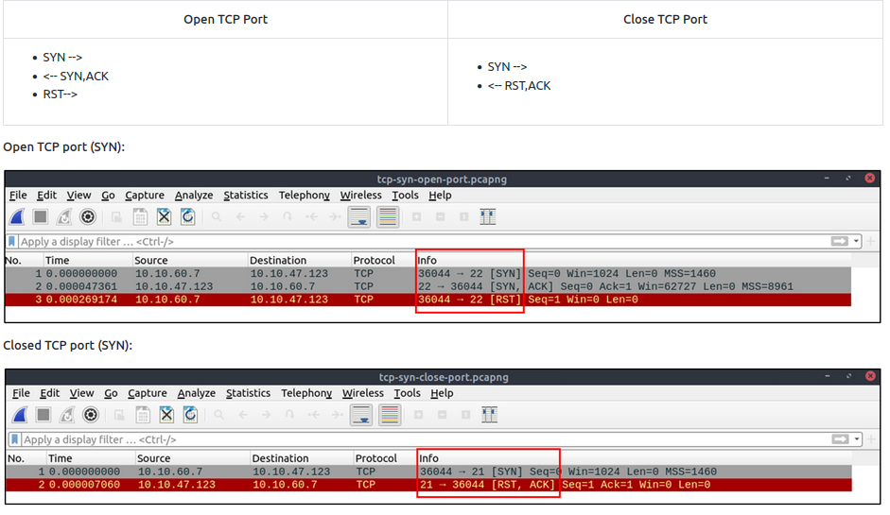

The given filter shows the TCP SYN scan patterns in a capture file.

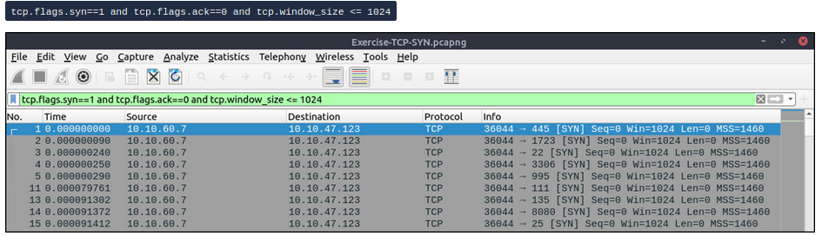

**UDP Scans**

UDP Scan in a nutshell:

* Doesn't require a handshake process
* No prompt for open ports
* ICMP error message for close ports
* Usually conducted with nmap -sU command.

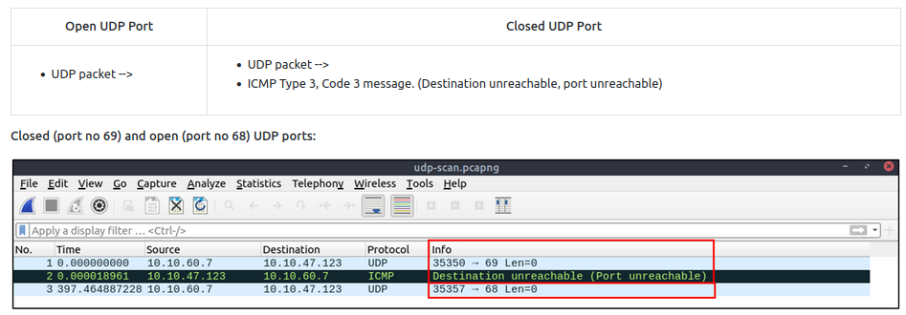

The above image shows that the closed port returns an ICMP error packet. No further information is provided about the error at first glance, so how can an analyst decide where this error message belongs? The ICMP error message uses the original request as encapsulated data to show the source/reason of the packet. Once you expand the ICMP section in the packet details pane, you will see the encapsulated data and the original request, as shown in the below image.

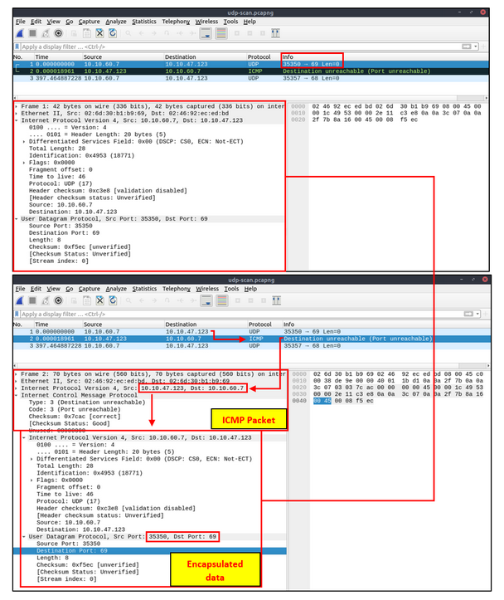

The given filter shows the UDP scan patterns in a capture file.

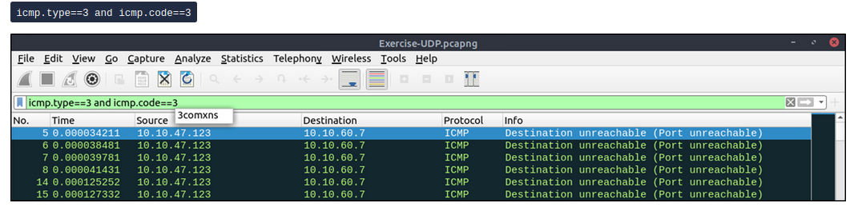

Detecting suspicious activities in chunked files is easy and a great way to learn how to focus on the details. Now use the exercise files to put your skills into practice against a single capture file and answer the questions below!

**Answer to the questions of this section-**

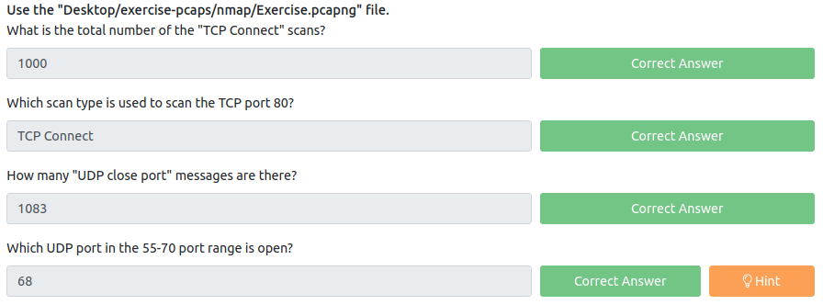

**Answers-**

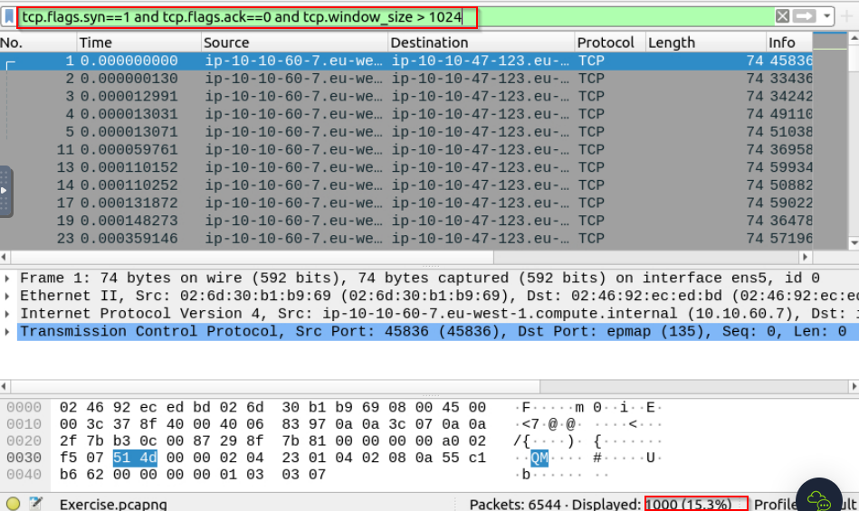

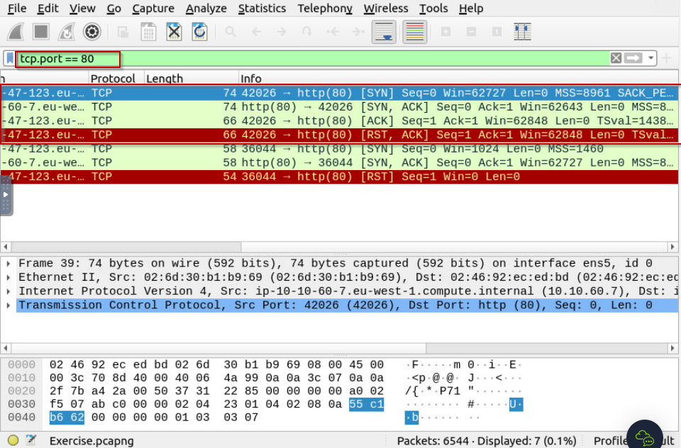

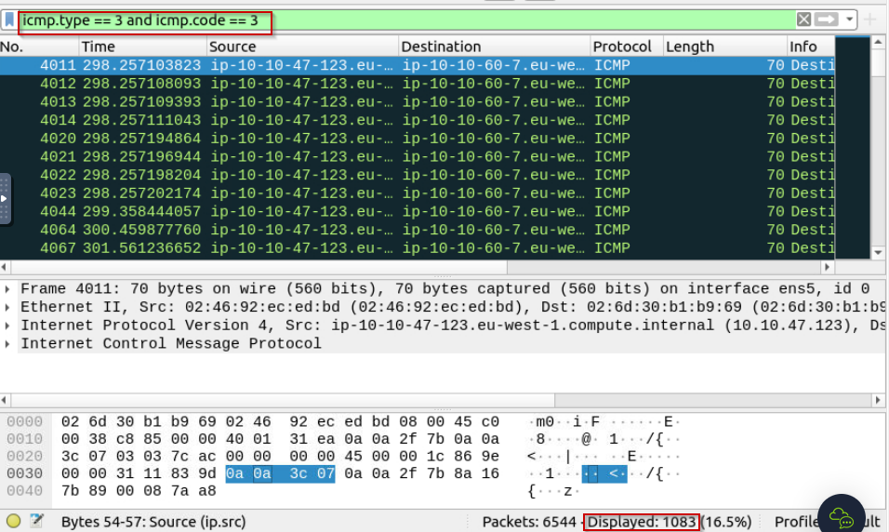

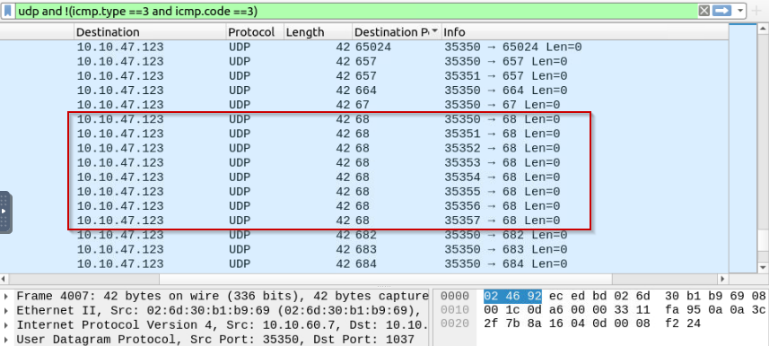

**Task 3 ARP Poisoning & Man In The Middle! –**

**ARP Poisoning/Spoofing (A.K.A. Man In The Middle Attack)**

ARP protocol, or Address Resolution Protocol (ARP), is the technology responsible for allowing devices to identify themselves on a network. Address Resolution Protocol Poisoning (also known as ARP Spoofing or Man In The Middle (MITM) attack) is a type of attack that involves network jamming/manipulating by sending malicious ARP packets to the default gateway. The ultimate aim is to manipulate the "IP to MAC address table" and sniff the traffic of the target host.

There are a variety of tools available to conduct ARP attacks. However, the mindset of the attack is static, so it is easy to detect such an attack by knowing the ARP protocol workflow and Wireshark skills.

ARP analysis in a nutshell:

* Works on the local network
* Enables the communication between MAC addresses
* Not a secure protocol
* Not a routable protocol
* It doesn't have an authentication function
* Common patterns are request & response, announcement and gratuitous packets.

Before investigating the traffic, let's review some legitimate and suspicious ARP packets. The legitimate requests are similar to the shown picture: a broadcast request that asks if any of the available hosts use an IP address and a reply from the host that uses the particular IP address.

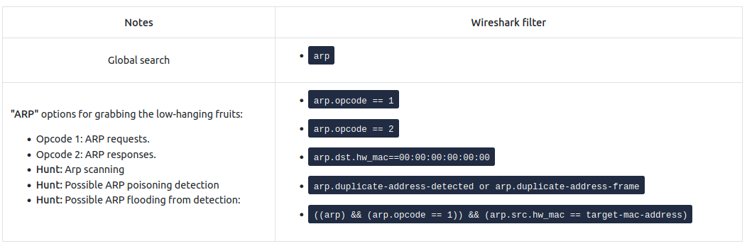

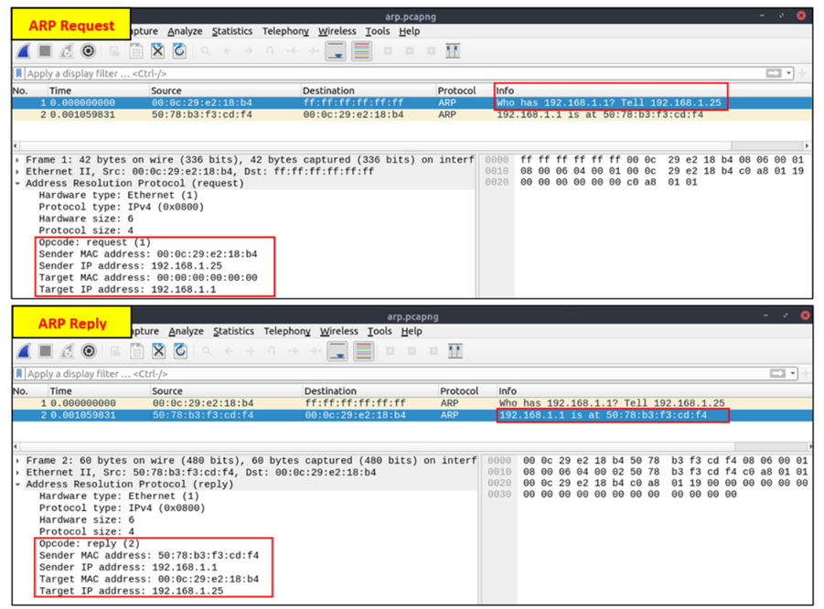

A suspicious situation means having two different ARP responses (conflict) for a particular IP address. In that case, Wireshark's expert info tab warns the analyst. However, it only shows the second occurrence of the duplicate value to highlight the conflict. Therefore, identifying the malicious packet from the legitimate one is the analyst's challenge. A possible IP spoofing case is shown in the picture below.

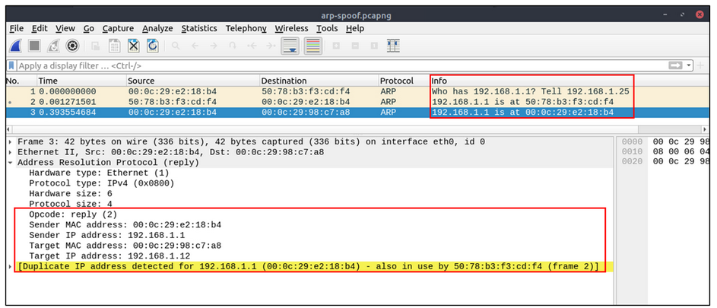

Here, knowing the network architecture and inspecting the traffic for a specific time frame can help detect the anomaly. As an analyst, you should take notes of your findings before going further. This will help you be organised and make it easier to correlate the further findings. Look at the given picture; there is a conflict; the MAC address that ends with "b4" crafted an ARP request with the "192.168.1.25" IP address, then claimed to have the "192.168.1.1" IP address.

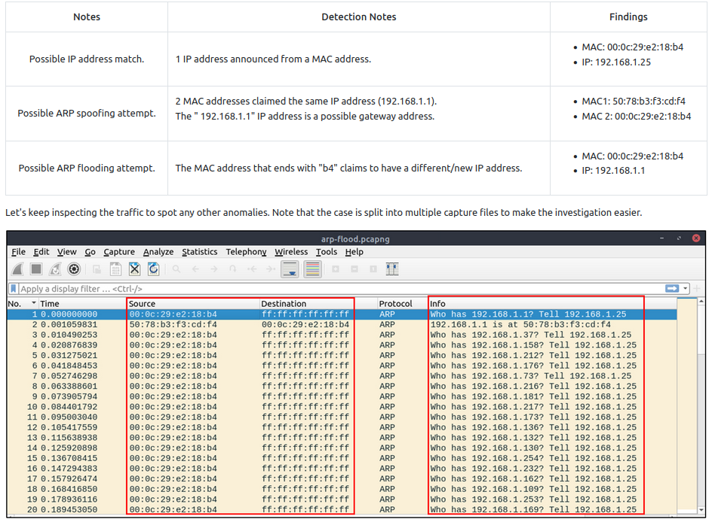

At this point, it is evident that there is an anomaly. A security analyst cannot ignore a flood of ARP requests. This could be malicious activity, scan or network problems. There is a new anomaly; the MAC address that ends with "b4" crafted multiple ARP requests with the "192.168.1.25" IP address. Let's focus on the source of this anomaly and extend the taken notes.

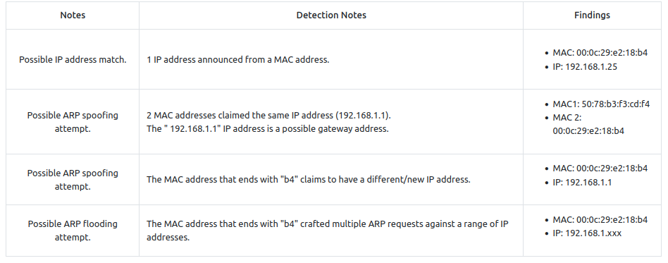

Up to this point, it is evident that the MAC address that ends with "b4" owns the "192.168.1.25" IP address and crafted suspicious ARP requests against a range of IP addresses. It also claimed to have the possible gateway address as well. Let's focus on other protocols and spot the reflection of this anomaly in the following sections of the time frame.

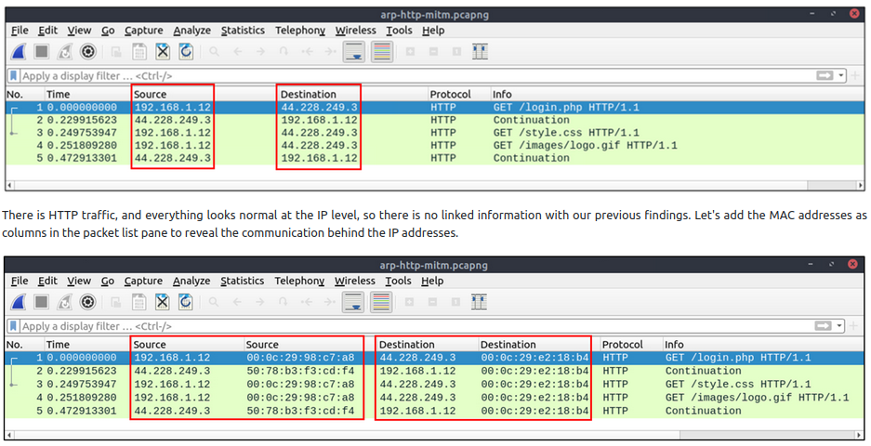

One more anomaly! The MAC address that ends with "b4" is the destination of all HTTP packets! It is evident that there is a MITM attack, and the attacker is the host with the MAC address that ends with "b4". All traffic linked to "192.168.1.12" IP addresses is forwarded to the malicious host. Let's summarise the findings before concluding the investigation.

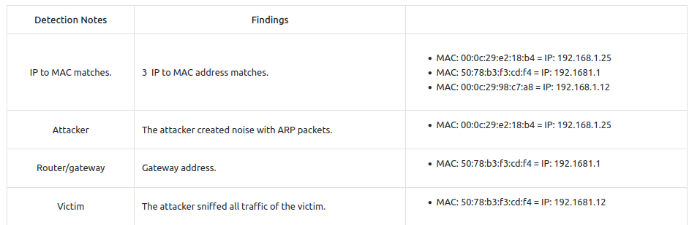

Detecting these bits and pieces of information in a big capture file is challenging. However, in real-life cases, you will not have "tailored data" ready for investigation. Therefore you need to have the analyst mindset, knowledge and tool skills to filter and detect the anomalies.

Note: In traffic analysis, there are always alternative solutions available. The solution type and the approach depend on the analyst's knowledge and skill level and the available data sources.

Detecting suspicious activities in chunked files is easy and a great way to learn how to focus on the details. Now use the exercise files to put your skills into practice against a single capture file and answer the questions below!

**Answer to the questions of this section-**

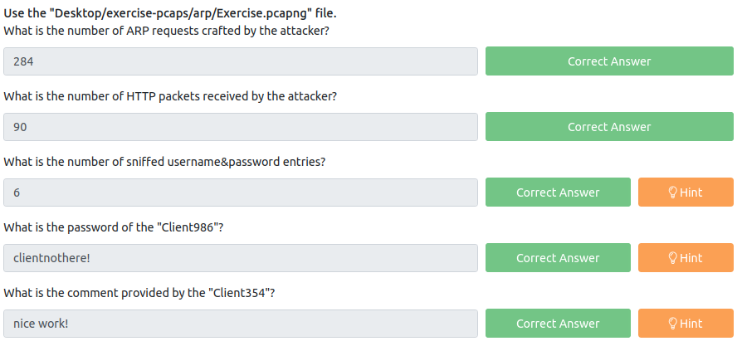

**Answers-**

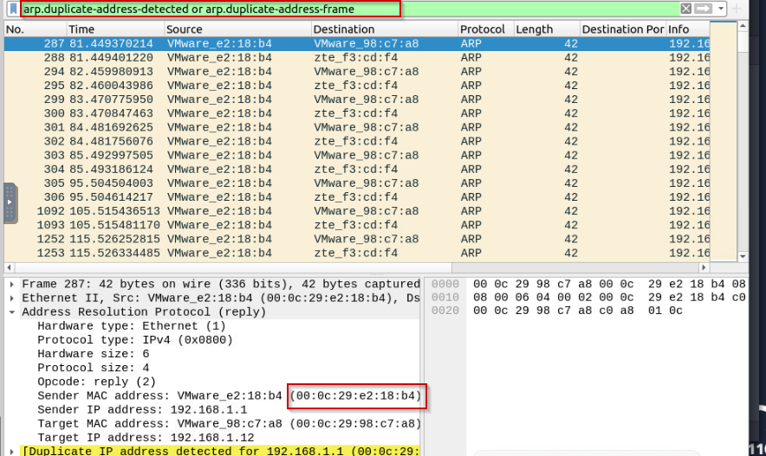

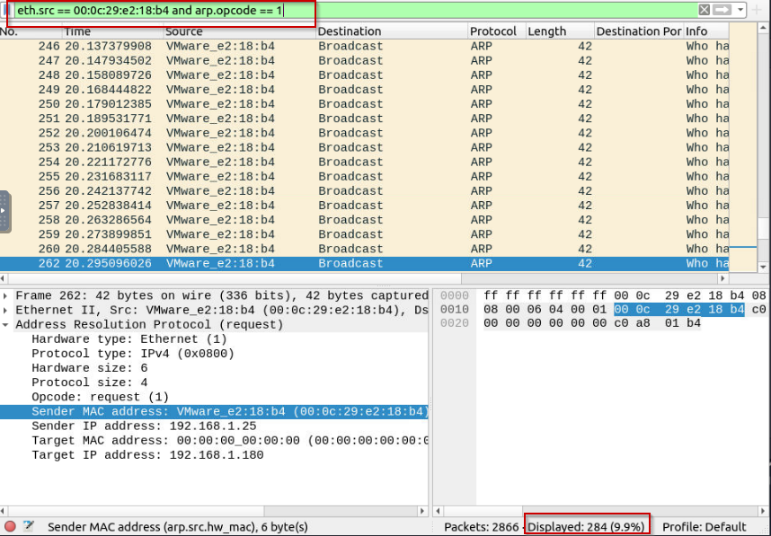

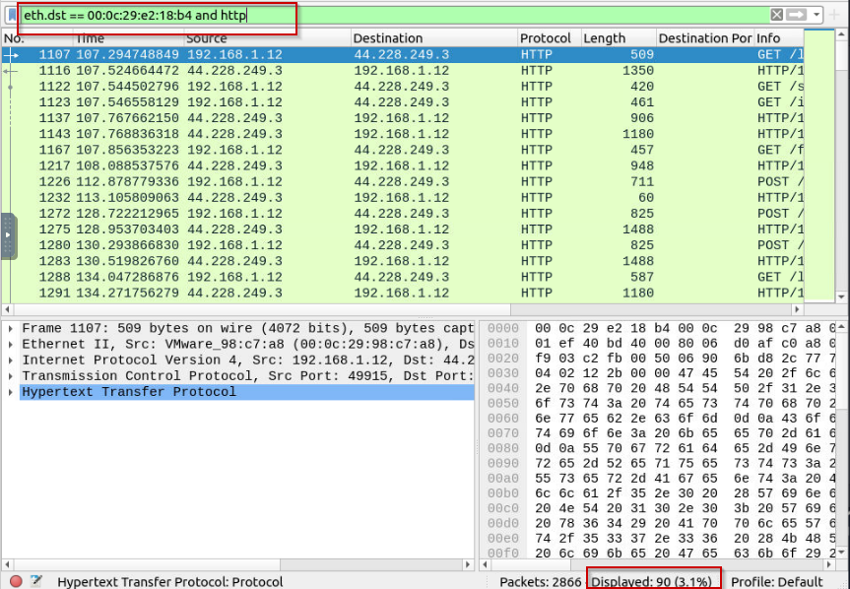

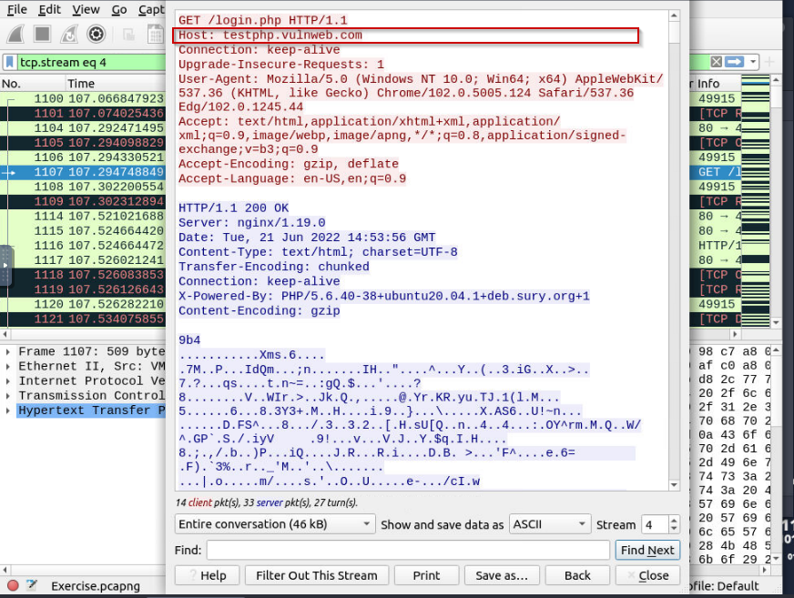

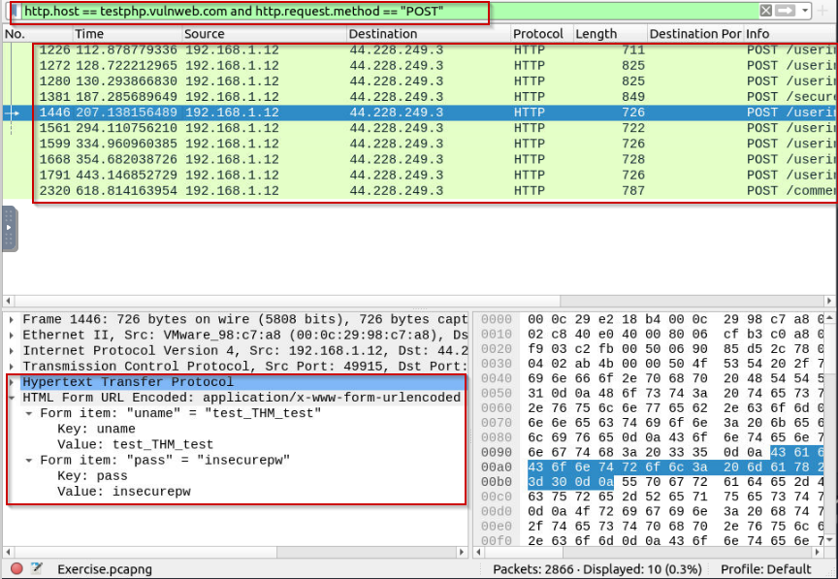

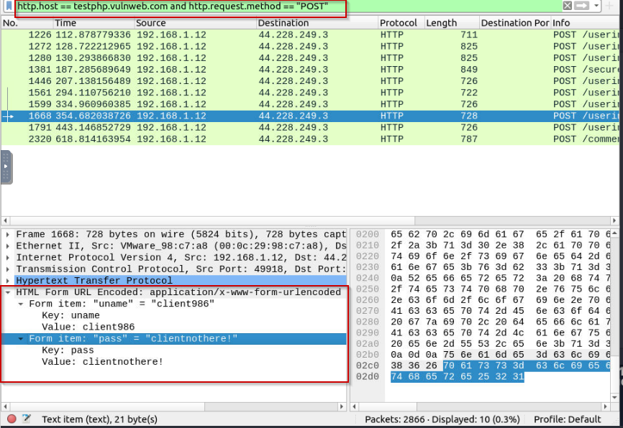

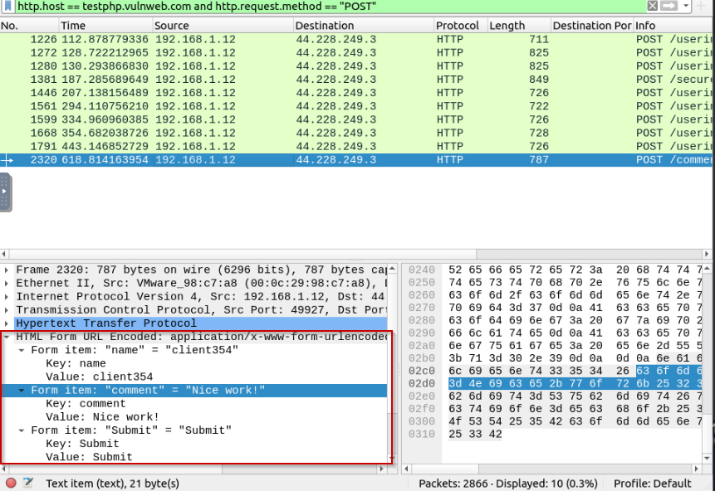

**Task 4 Identifying Hosts: DHCP, NetBIOS and Kerberos –**

**Identifying Hosts**

When investigating a compromise or malware infection activity, a security analyst should know how to identify the hosts on the network apart from IP to MAC address match. One of the best methods is identifying the hosts and users on the network to decide the investigation's starting point and list the hosts and users associated with the malicious traffic/activity.

Usually, enterprise networks use a predefined pattern to name users and hosts. While this makes knowing and following the inventory easier, it has good and bad sides. The good side is that it will be easy to identify a user or host by looking at the name. The bad side is that it will be easy to clone that pattern and live in the enterprise network for adversaries. There are multiple solutions to avoid these kinds of activities, but for a security analyst, it is still essential to have host and user identification skills.

Protocols that can be used in Host and User identification:

* Dynamic Host Configuration Protocol (DHCP) traffic
* NetBIOS (NBNS) traffic
* Kerberos traffic

**DHCP Analysis**

DHCP protocol, or Dynamic Host Configuration Protocol (DHCP), is the technology responsible for managing automatic IP address and required communication parameters assignment.

DHCP investigation in a nutshell:

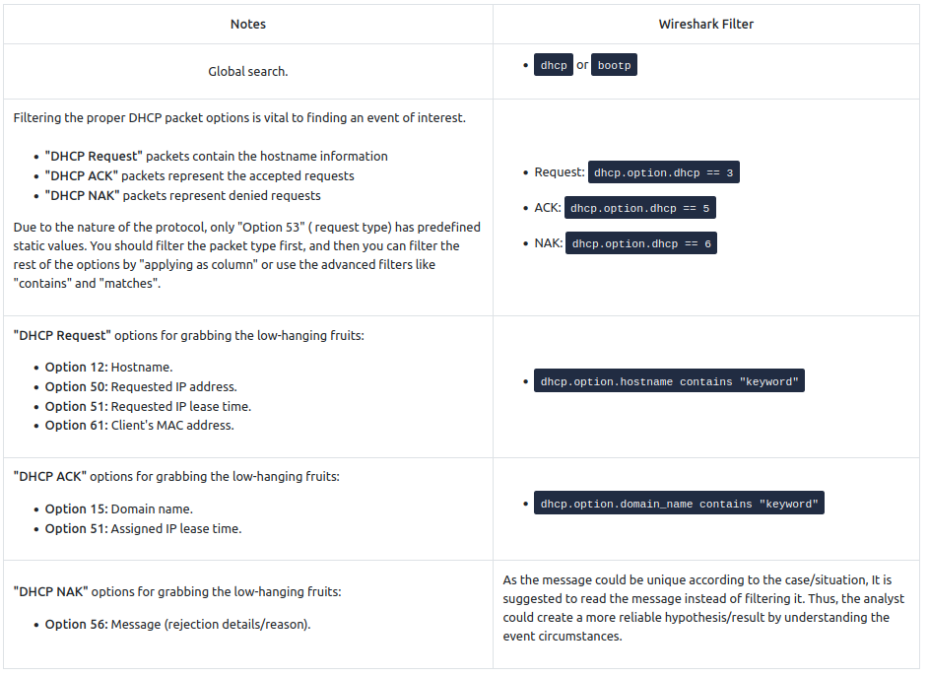

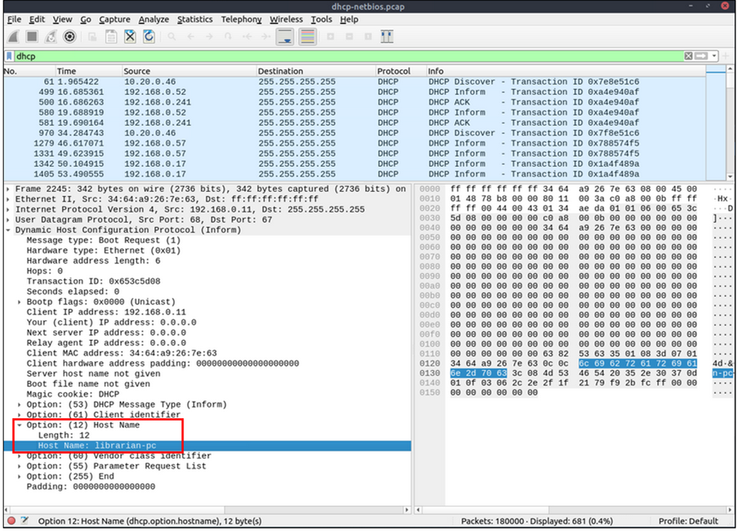

**NetBIOS (NBNS) Analysis**

NetBIOS or Network Basic Input/Output System is the technology responsible for allowing applications on different hosts to communicate with each other.

NBNS investigation in a nutshell:

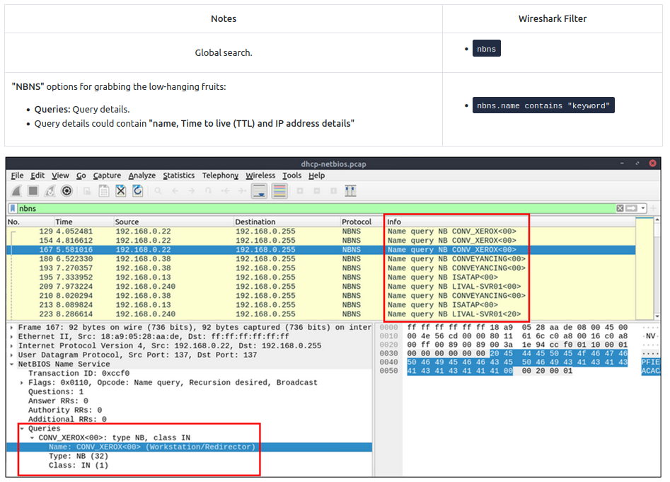

**Kerberos Analysis**

Kerberos is the default authentication service for Microsoft Windows domains. It is responsible for authenticating service requests between two or more computers over the untrusted network. The ultimate aim is to prove identity securely.

Kerberos investigation in a nutshell:

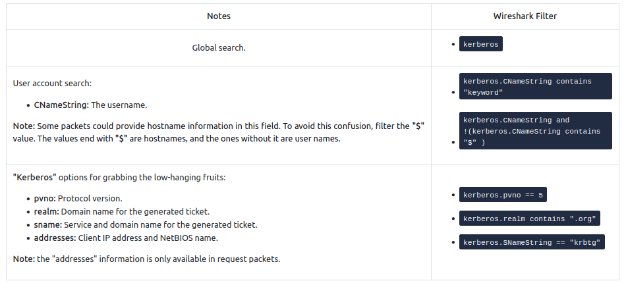

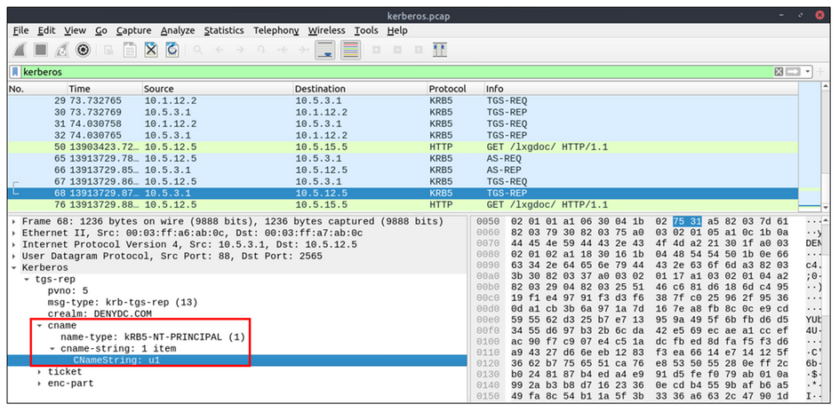

Detecting suspicious activities in chunked files is easy and a great way to learn how to focus on the details. Now use the exercise files to put your skills into practice against a single capture file and answer the questions below!

**Answer to the questions of this section-**

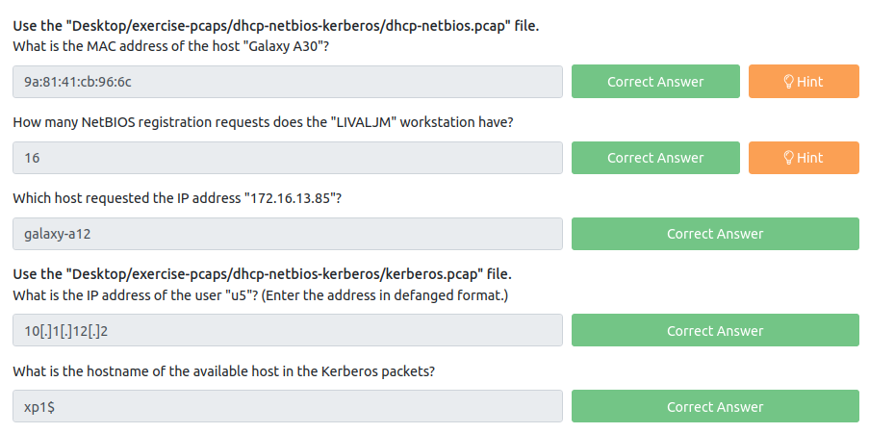

**Answers-**

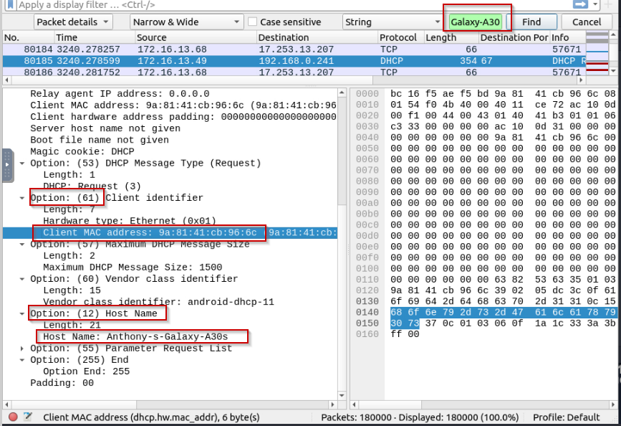

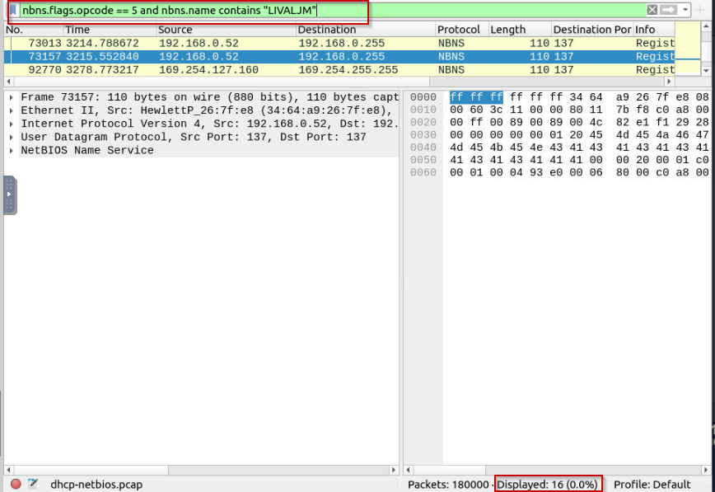

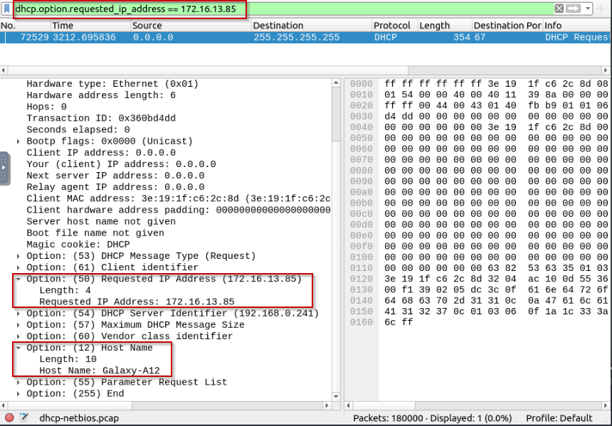

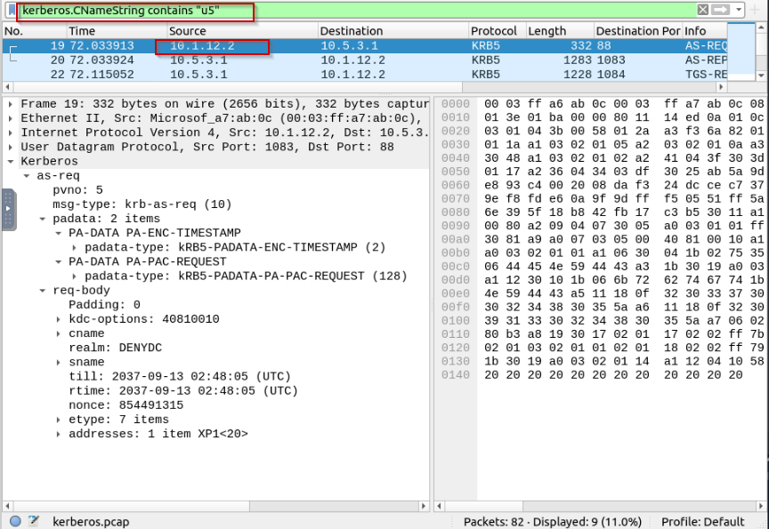

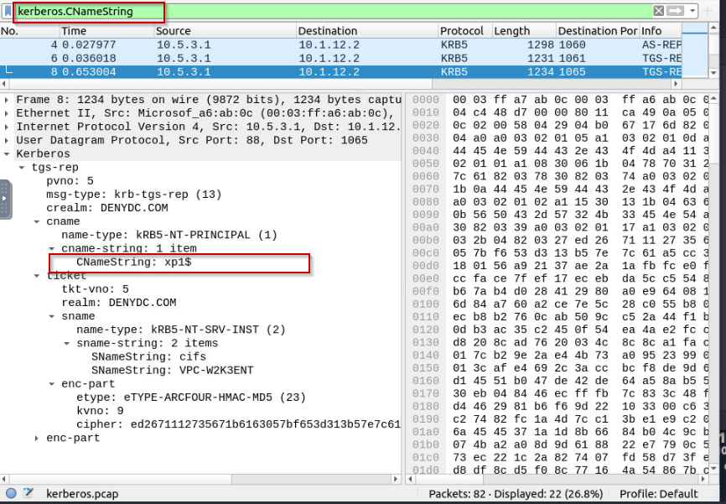

**Task 5 Tunneling Traffic: DNS and ICMP –**

**Tunnelling Traffic: ICMP and DNS**

Traffic tunnelling is (also known as "port forwarding") transferring the data/resources in a secure method to network segments and zones. It can be used for "internet to private networks" and "private networks to internet" flow/direction. There is an encapsulation process to hide the data, so the transferred data appear natural for the case, but it contains private data packets and transfers them to the final destination securely.

Tunnelling provides anonymity and traffic security. Therefore it is highly used by enterprise networks. However, as it gives a significant level of data encryption, attackers use tunnelling to bypass security perimeters using the standard and trusted protocols used in everyday traffic like ICMP and DNS. Therefore, for a security analyst, it is crucial to have the ability to spot ICMP and DNS anomalies.

**ICMP Analysis**

Internet Control Message Protocol (ICMP) is designed for diagnosing and reporting network communication issues. It is highly used in error reporting and testing. As it is a trusted network layer protocol, sometimes it is used for denial of service (DoS) attacks; also, adversaries use it in data exfiltration and C2 tunnelling activities.

ICMP analysis in a nutshell:

Usually, ICMP tunnelling attacks are anomalies appearing/starting after a malware execution or vulnerability exploitation. As the ICMP packets can transfer an additional data payload, adversaries use this section to exfiltrate data and establish a C2 connection. It could be a TCP, HTTP or SSH data. As the ICMP protocols provide a great opportunity to carry extra data, it also has disadvantages. Most enterprise networks block custom packets or require administrator privileges to create custom ICMP packets.

A large volume of ICMP traffic or anomalous packet sizes are indicators of ICMP tunnelling. Still, the adversaries could create custom packets that match the regular ICMP packet size (64 bytes), so it is still cumbersome to detect these tunnelling activities. However, a security analyst should know the normal and the abnormal to spot the possible anomaly and escalate it for further analysis.

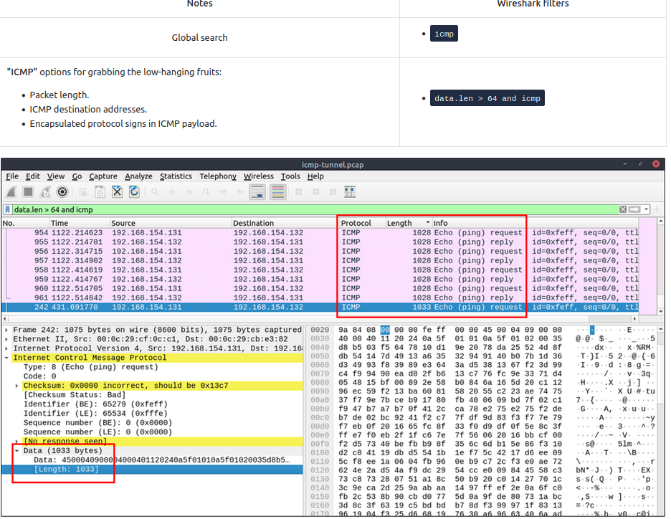

**DNS Analysis**

Domain Name System (DNS) is designed to translate/convert IP domain addresses to IP addresses. It is also known as a phonebook of the internet. As it is the essential part of web services, it is commonly used and trusted, and therefore often ignored. Due to that, adversaries use it in data exfiltration and C2 activities.

DNS analysis in a nutshell:

Similar to ICMP tunnels, DNS attacks are anomalies appearing/starting after a malware execution or vulnerability exploitation. Adversary creates (or already has) a domain address and configures it as a C2 channel. The malware or the commands executed after exploitation sends DNS queries to the C2 server. However, these queries are longer than default DNS queries and crafted for subdomain addresses. Unfortunately, these subdomain addresses are not actual addresses; they are encoded commands as shown below:

**"encoded-commands.maliciousdomain.com"**

When this query is routed to the C2 server, the server sends the actual malicious commands to the host. As the DNS queries are a natural part of the networking activity, these packets have the chance of not being detected by network perimeters. A security analyst should know how to investigate the DNS packet lengths and target addresses to spot these anomalies.

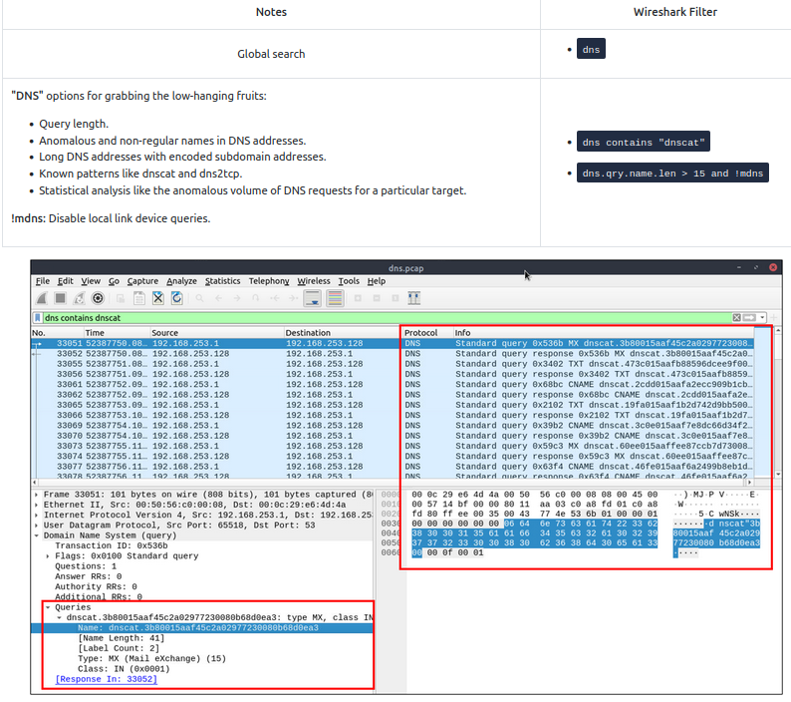

Detecting suspicious activities in chunked files is easy and a great way to learn how to focus on the details. Now use the exercise files to put your skills into practice against a single capture file and answer the questions below!

**Answer to the questions of this section-**

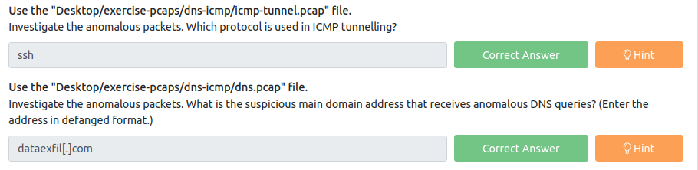

**Answers-**

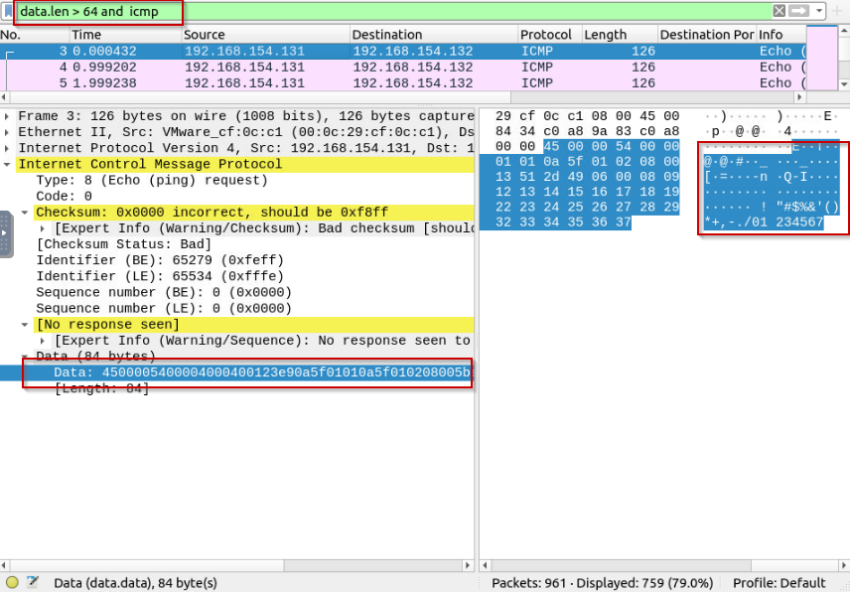

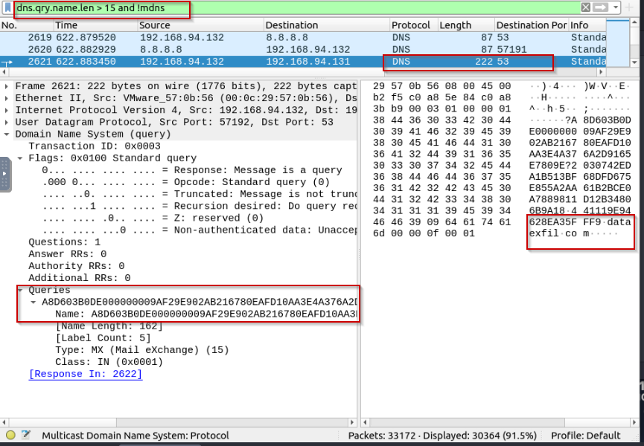

Have Fun and Enjoy Hacking! Do visit other rooms and modules on TryHackMe for more learning.

-by Shefali Kumai

For more cyber security learning follow me here-

<https://www.youtube.com/channel/UCf-F-eATCUXYaUVk8Xl7OOQ>

<https://www.instagram.com/cybersecurity.cyber_seek/>

**Task 6 Cleartext Protocol Analysis: FTP –**

**Cleartext Protocol Analysis**

Investigating cleartext protocol traces sounds easy, but when the time comes to investigate a big network trace for incident analysis and response, the game changes. Proper analysis is more than following the stream and reading the cleartext data. For a security analyst, it is important to create statistics and key results from the investigation process. As mentioned earlier at the beginning of the Wireshark room series, the analyst should have the required network knowledge and tool skills to accomplish this. Let's simulate a cleartext protocol investigation with Wireshark!

**FTP Analysis**

File Transfer Protocol (FTP) is designed to transfer files with ease, so it focuses on simplicity rather than security. As a result of this, using this protocol in unsecured environments could create security issues like:

* MITM attacks
* Credential stealing and unauthorised access
* Phishing
* Malware planting
* Data exfiltration

FTP analysis in a nutshell:

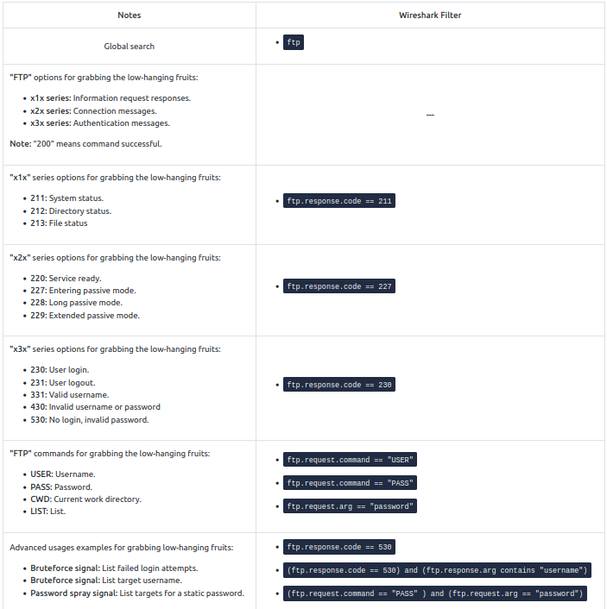

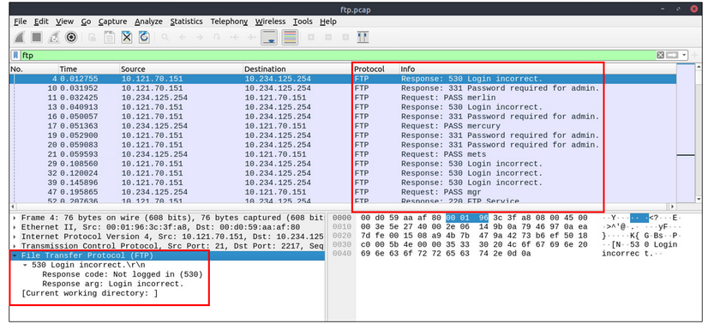

Detecting suspicious activities in chunked files is easy and a great way to learn how to focus on the details. Now use the exercise files to put your skills into practice against a single capture file and answer the questions below!

**Answer to the questions of this section-**

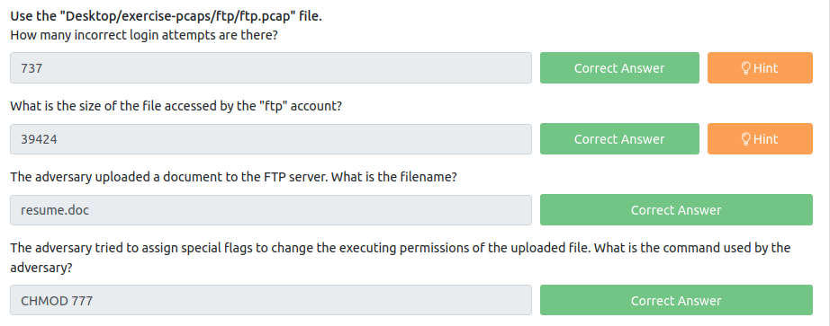

**Answers-**

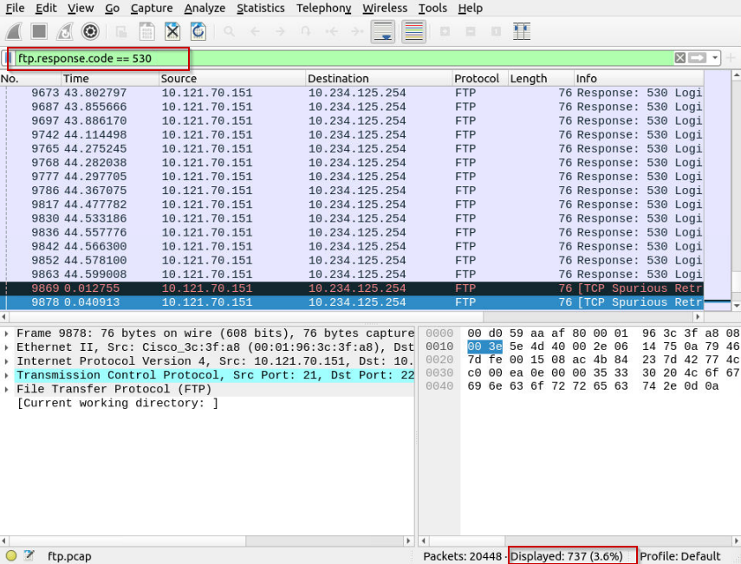

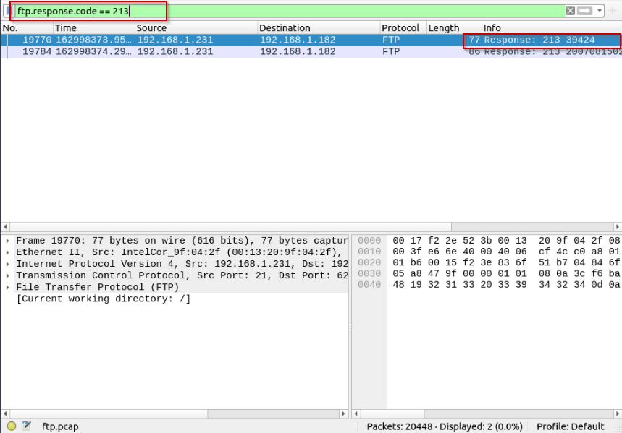

**Do right click on the highlighted alert (in blue), and select TCP follow to read data follow.**

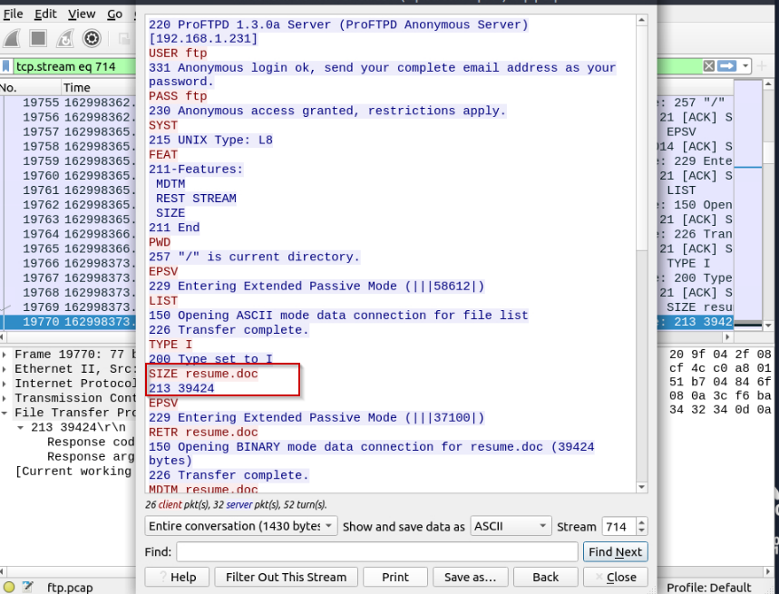

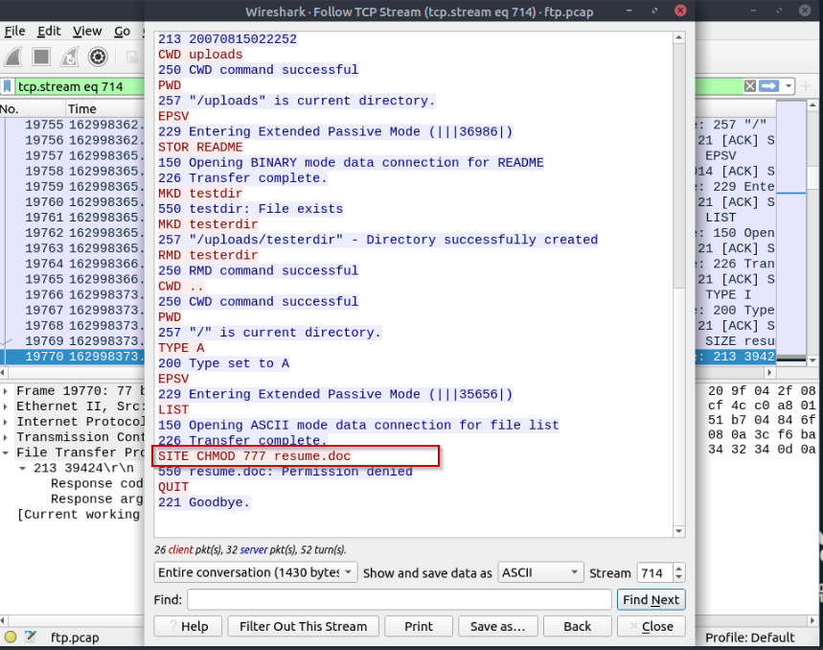

**Task 7 Cleartext Protocol Analysis: HTTP –**

**HTTP Analysis**

Hypertext Transfer Protocol (HTTP) is a cleartext-based, request-response and client-server protocol. It is the standard type of network activity to request/serve web pages, and by default, it is not blocked by any network perimeter. As a result of being unencrypted and the backbone of web traffic, HTTP is one of the must-to-know protocols in traffic analysis. Following attacks could be detected with the help of HTTP analysis:

* Phishing pages
* Web attacks
* Data exfiltration
* Command and control traffic (C2)

HTTP analysis in a nutshell:

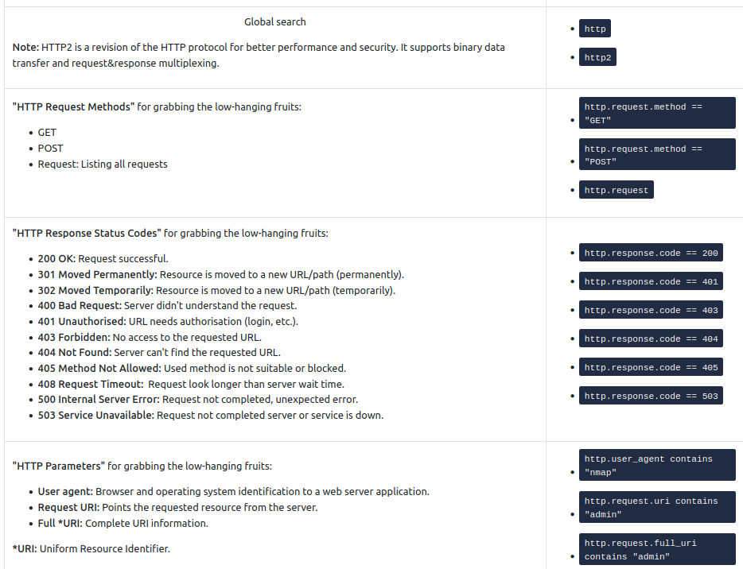

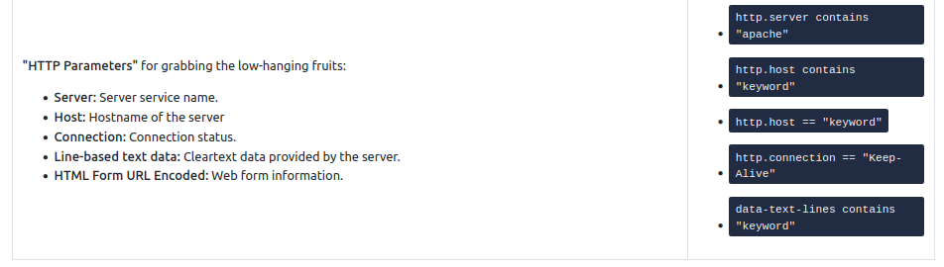

**User Agent Analysis**

As the adversaries use sophisticated technics to accomplish attacks, they try to leave traces similar to natural traffic through the known and trusted protocols. For a security analyst, it is important to spot the anomaly signs on the bits and pieces of the packets. The "user-agent" field is one of the great resources for spotting anomalies in HTTP traffic. In some cases, adversaries successfully modify the user-agent data, which could look super natural. A security analyst cannot rely only on the user-agent field to spot an anomaly. Never whitelist a user agent, even if it looks natural. User agent-based anomaly/threat detection/hunting is an additional data source to check and is useful when there is an obvious anomaly. If you are unsure about a value, you can conduct a web search to validate your findings with the default and normal user-agent info ([example site](https://developers.whatismybrowser.com/useragents/explore/)).

User Agent analysis in a nutshell:

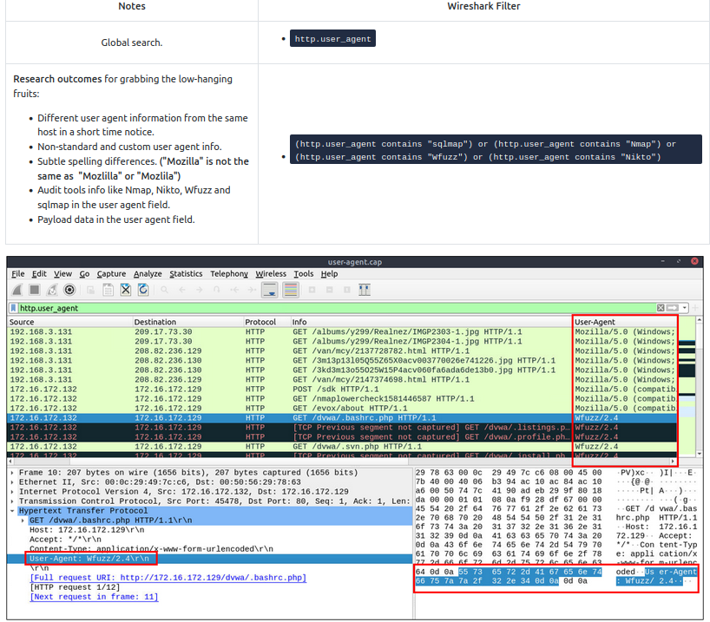

**Log4j Analysis**

A proper investigation starts with prior research on threats and anomalies going to be hunted. Let's review the knowns on the "Log4j" attack before launching Wireshark.

Log4j vulnerability analysis in a nutshell:

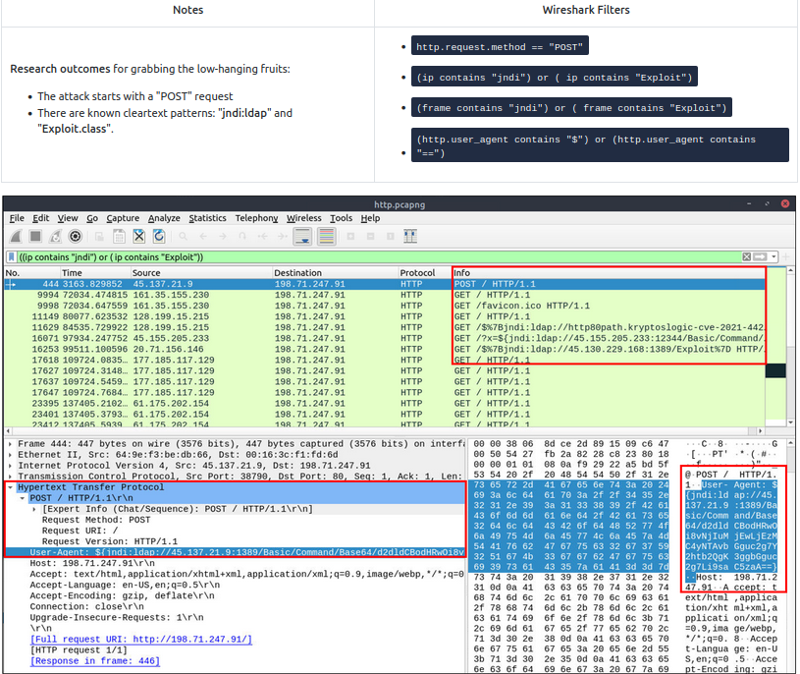

Detecting suspicious activities in chunked files is easy and a great way to learn how to focus on the details. Now use the exercise files to put your skills into practice against a single capture file and answer the questions below!

**Answer to the questions of this section-**

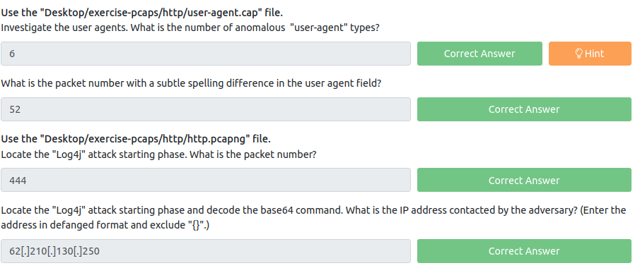

**Answers-**

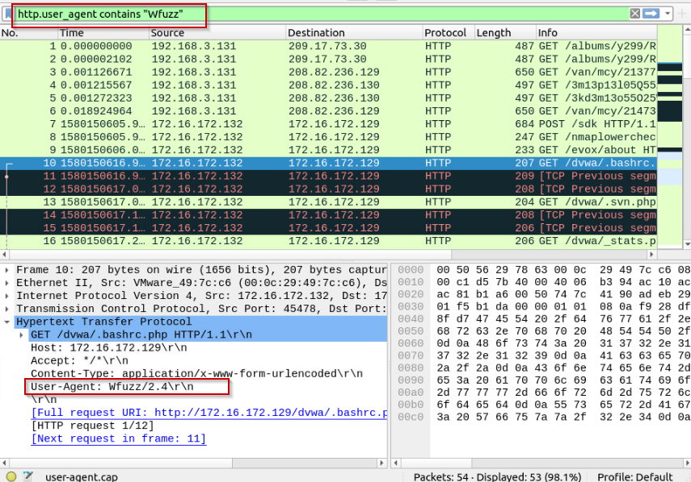

**Type http.user_agent in filter and right click on user agent to apply it as column**

**(http.user_agent contains "Wfuzz") or (http.user_agent contains "Sqlmap") or (http.user_agent contains "nmap") or (http.user_agent contains "Mozlila") or (http.user_agent contains "$")**

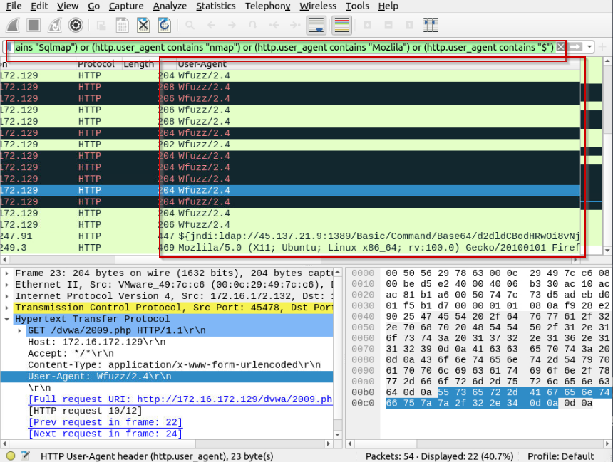

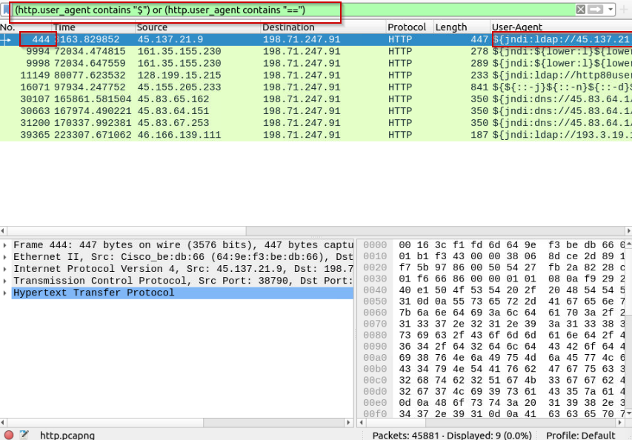

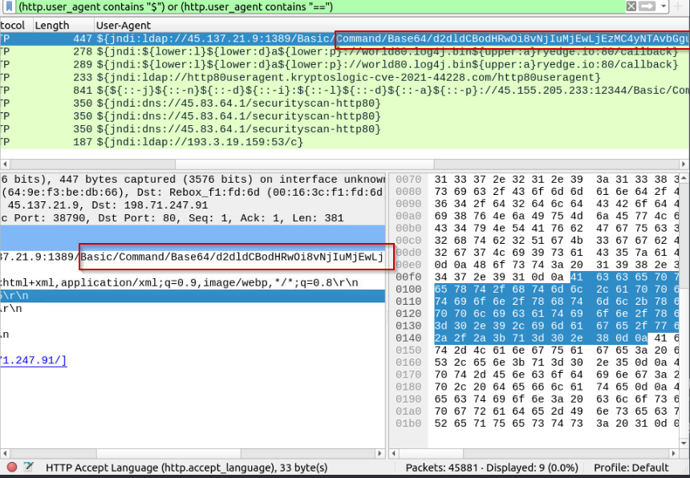

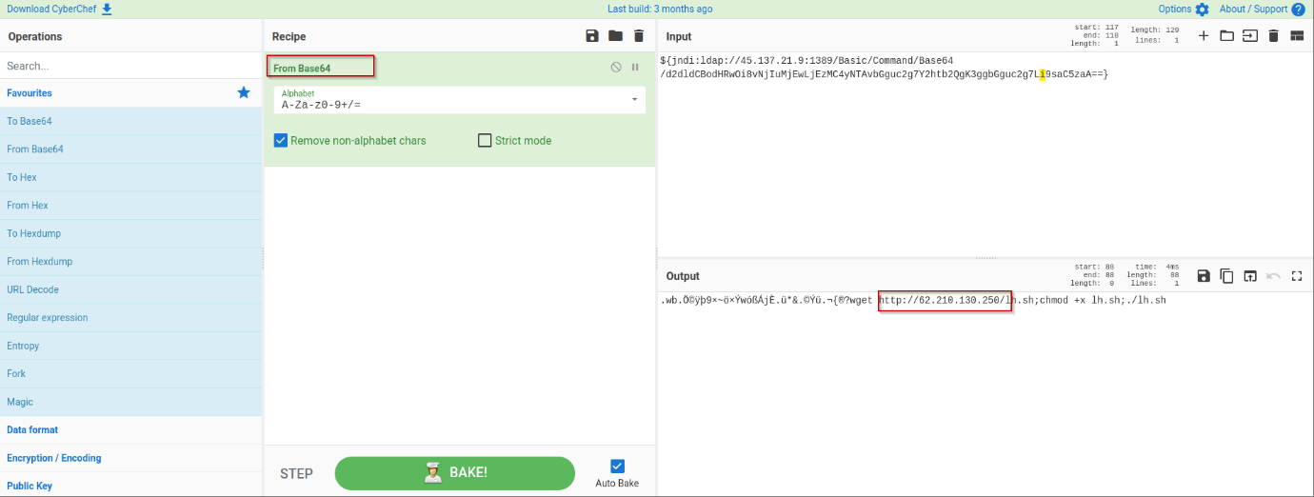

**Task 8 Encrypted Protocol Analysis: Decrypting HTTPS –**

**Decrypting HTTPS Traffic**

When investigating web traffic, analysts often run across encrypted traffic. This is caused by using the Hypertext Transfer Protocol Secure (HTTPS) protocol for enhanced security against spoofing, sniffing and intercepting attacks. HTTPS uses TLS protocol to encrypt communications, so it is impossible to decrypt the traffic and view the transferred data without having the encryption/decryption key pairs. As this protocol provides a good level of security for transmitting sensitive data, attackers and malicious websites also use HTTPS. Therefore, a security analyst should know how to use key files to decrypt encrypted traffic and investigate the traffic activity.

The packets will appear in different colours as the HTTP traffic is encrypted. Also, protocol and info details (actual URL address and data returned from the server) will not be fully visible. The first image below shows the HTTP packets encrypted with the TLS protocol. The second and third images demonstrate filtering HTTP packets without using a key log file.

Additional information for HTTPS :

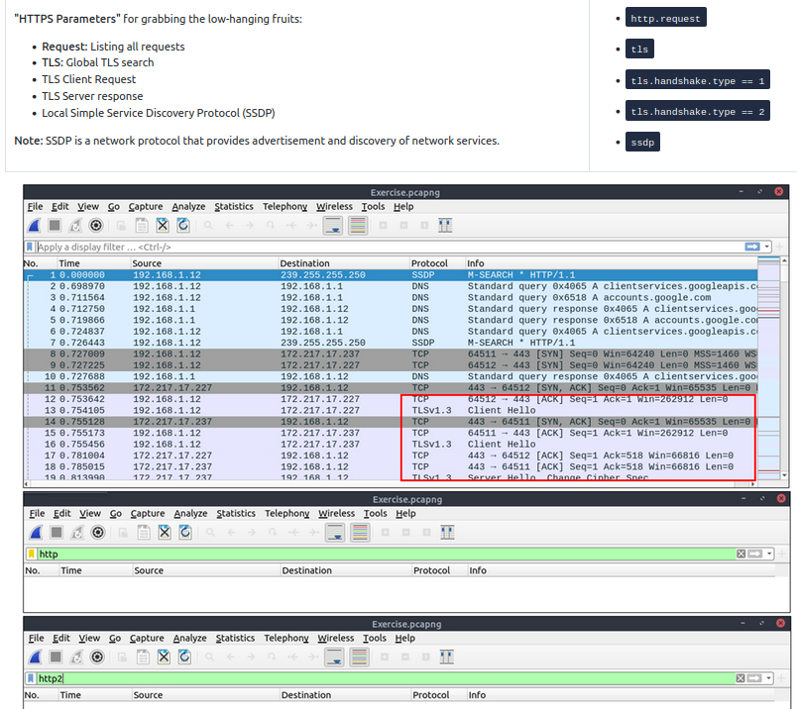

Similar to the TCP three-way handshake process, the TLS protocol has its handshake process. The first two steps contain "Client Hello" and "Server Hello" messages. The given filters show the initial hello packets in a capture file. These filters are helpful to spot which IP addresses are involved in the TLS handshake.

Client Hello: (http.request or tls.handshake.type == 1) and !(ssdp)

Server Hello: (http.request or tls.handshake.type == 2) and !(ssdp)

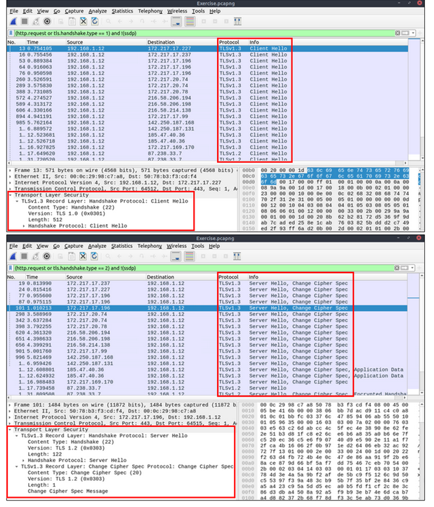

An encryption key log file is a text file that contains unique key pairs to decrypt the encrypted traffic session. These key pairs are automatically created (per session) when a connection is established with an SSL/TLS-enabled webpage. As these processes are all accomplished in the browser, you need to configure your system and use a suitable browser (Chrome and Firefox support this) to save these values as a key log file. To do this, you will need to set up an environment variable and create the SSLKEYLOGFILE, and the browser will dump the keys to this file as you browse the web. SSL/TLS key pairs are created per session at the connection time, so it is important to dump the keys during the traffic capture. Otherwise, it is not possible to create/generate a suitable key log file to decrypt captured traffic. You can use the "right-click" menu or "Edit --> Preferences --> Protocols --> TLS" menu to add/remove key log files.

Adding key log files with the "right-click" menu:

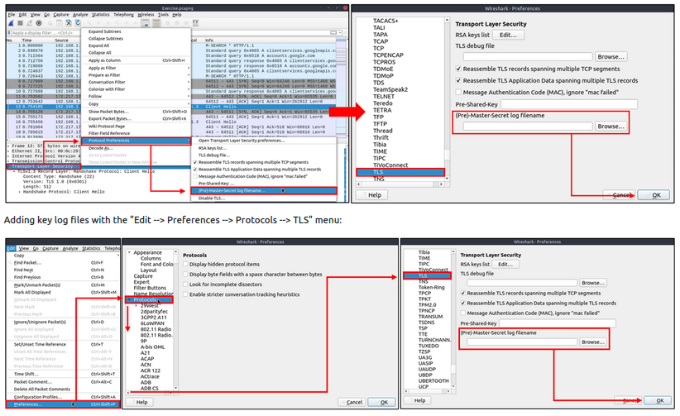

Viewing the traffic with/without the key log files:

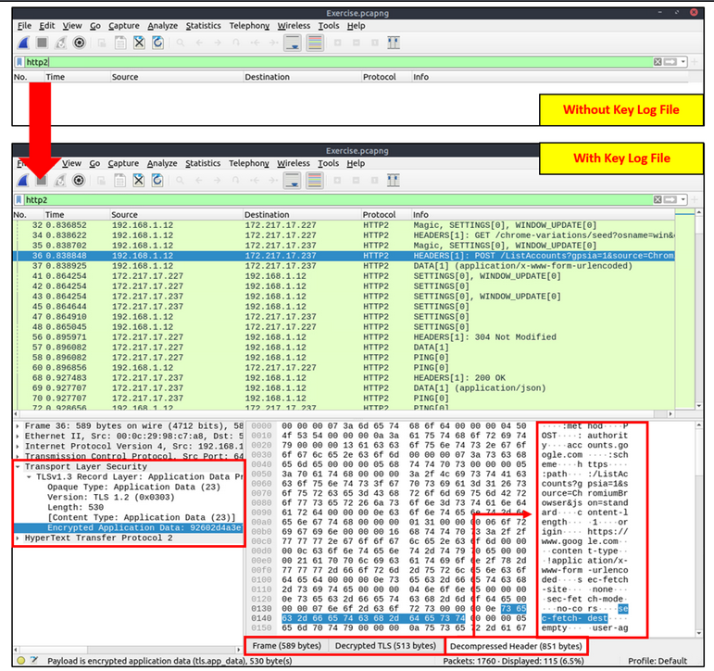

The above image shows that the traffic details are visible after using the key log file. Note that the packet details and bytes pane provides the data in different formats for investigation. Decompressed header info and HTTP2 packet details are available after decrypting the traffic. Depending on the packet details, you can also have the following data formats:

* Frame
* Decrypted TLS
* Decompressed Header
* Reassembled TCP
* Reassembled SSL

Detecting suspicious activities in chunked files is easy and a great way to learn how to focus on the details. Now use the exercise files to put your skills into practice against a single capture file and answer the questions below!

**Answer to the questions of this section-**

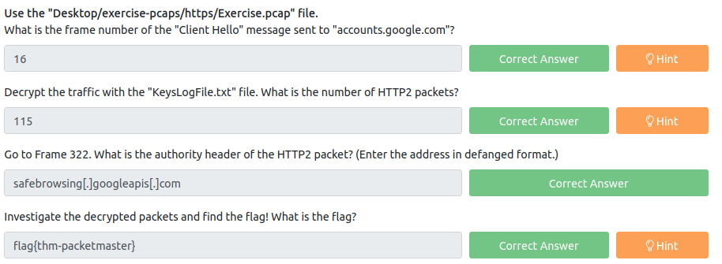

**Answers-**

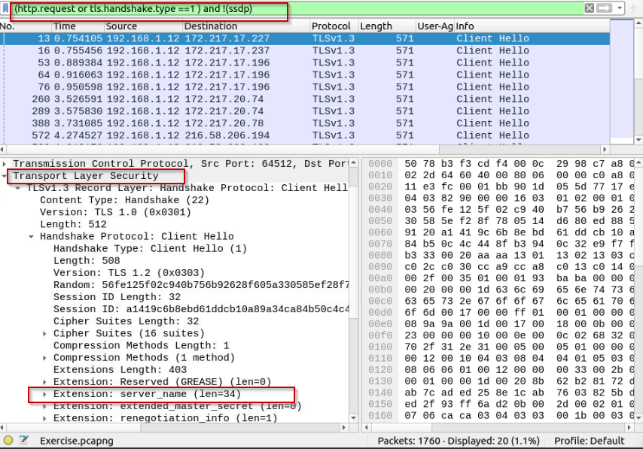

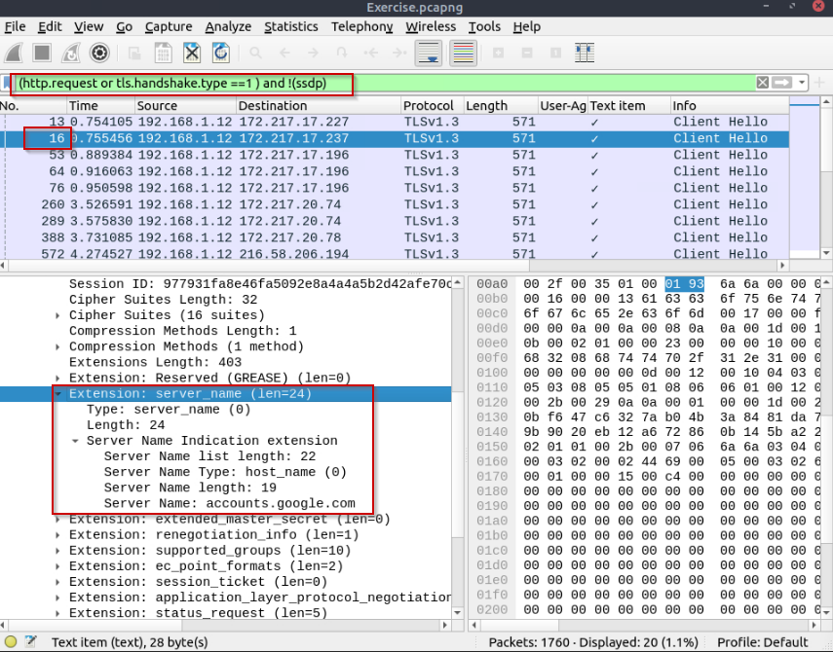

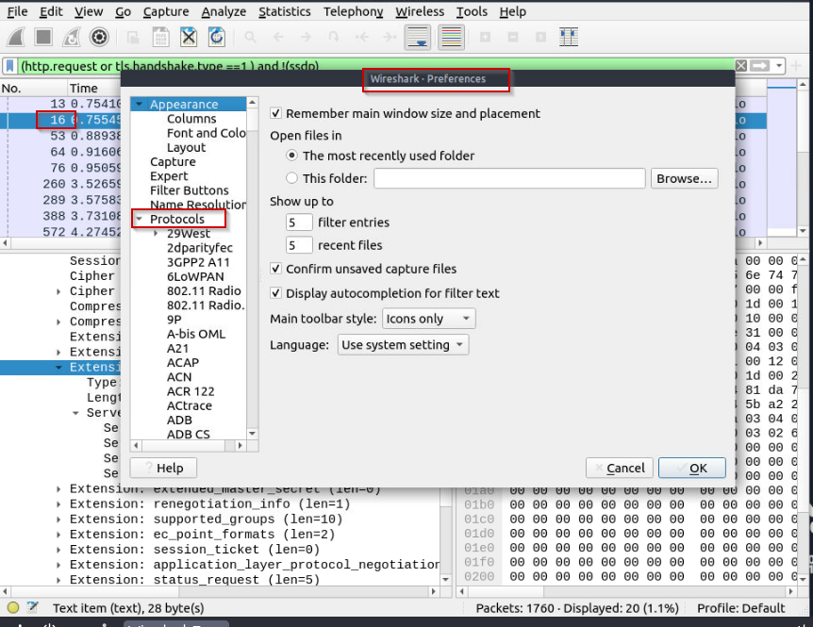

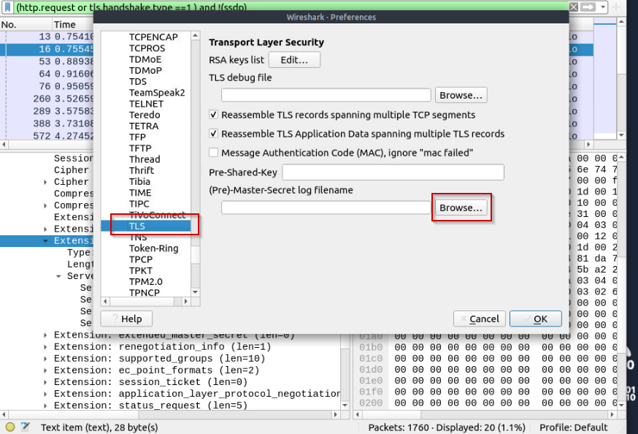

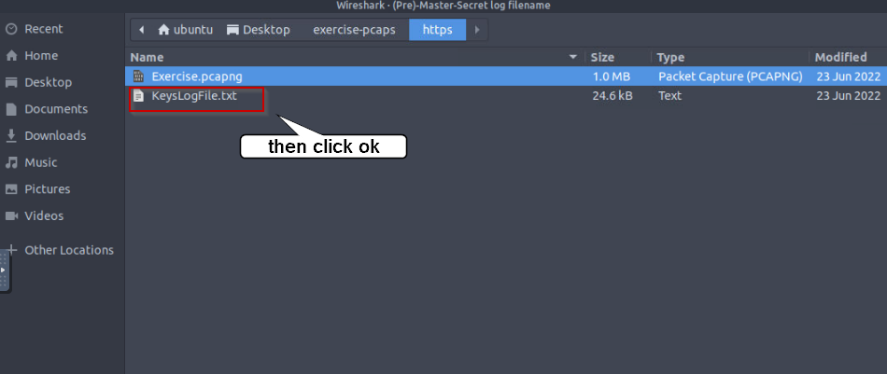

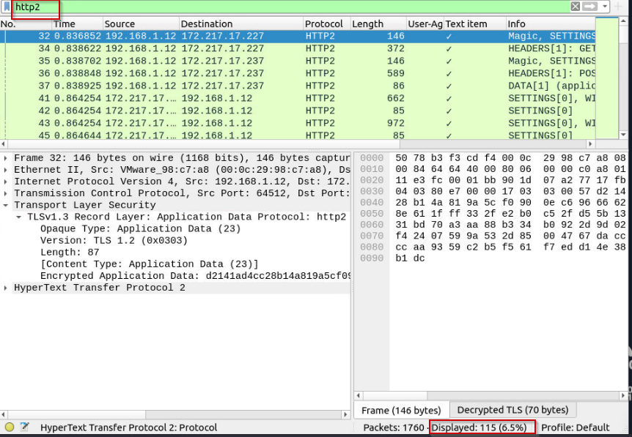

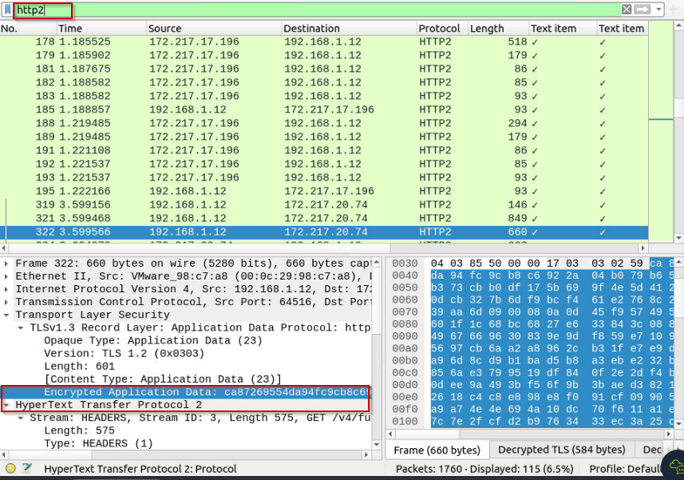

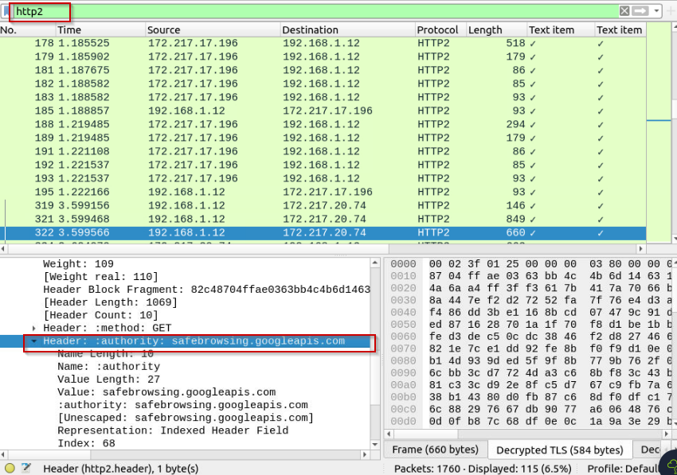

**Click on file option, select export object -> select HTTP object link and save the file to click open and view flag later.**

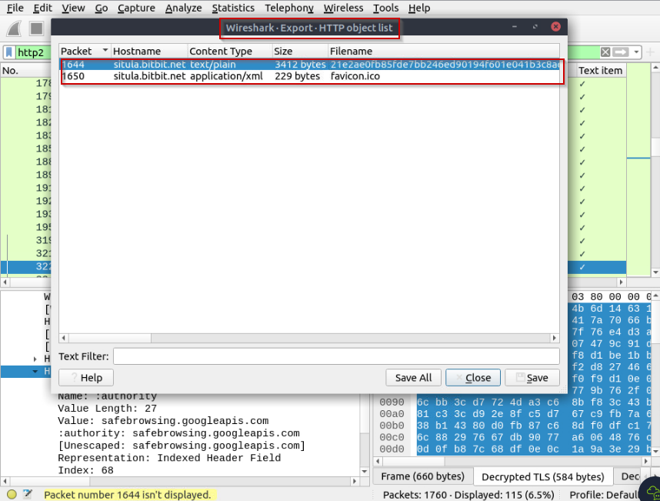

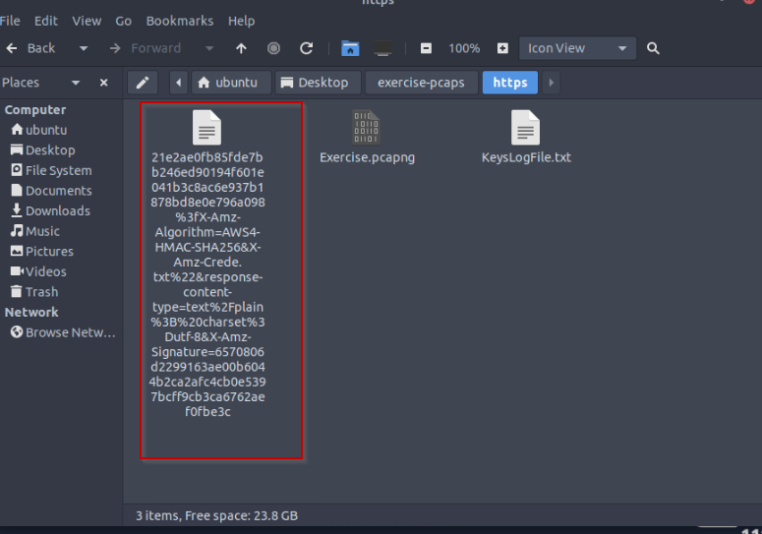

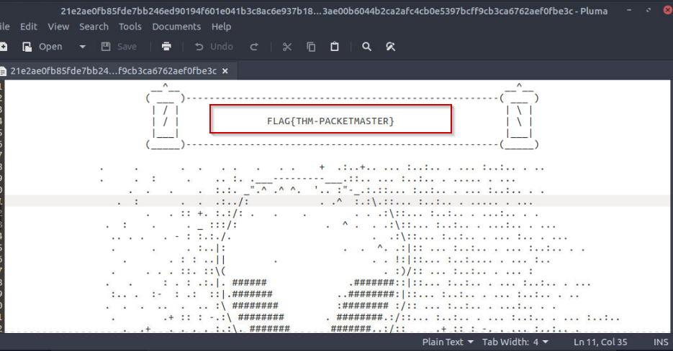

**Task 9 Bonus: Hunt Cleartext Credentials! –**

**Bonus: Hunt Cleartext Credentials!**

Up to here, we discussed how to inspect the packets for specific conditions and spot anomalies. As mentioned in the first room, Wireshark is not an IDS, but it provides suggestions for some cases under the expert info. However, sometimes anomalies replicate the legitimate traffic, so the detection becomes harder. For example, in a cleartext credential hunting case, it is not easy to spot the multiple credential inputs and decide if there is a brute-force attack or if it is a standard user who mistyped their credentials.

As everything is presented at the packet level, it is hard to spot the multiple username/password entries at first glance. The detection time will decrease when an analyst can view the credential entries as a list. Wireshark has such a feature to help analysts who want to hunt cleartext credential entries.

Some Wireshark dissectors (FTP, HTTP, IMAP, pop and SMTP) are programmed to extract cleartext passwords from the capture file. You can view detected credentials using the "Tools --> Credentials" menu. This feature works only after specific versions of Wireshark (v3.1 and later). Since the feature works only with particular protocols, it is suggested to have manual checks and not entirely rely on this feature to decide if there is a cleartext credential in the traffic.

Once you use the feature, it will open a new window and provide detected credentials. It will show the packet number, protocol, username and additional information. This window is clickable; clicking on the packet number will select the packet containing the password, and clicking on the username will select the packet containing the username info. The additional part prompts the packet number that contains the username.

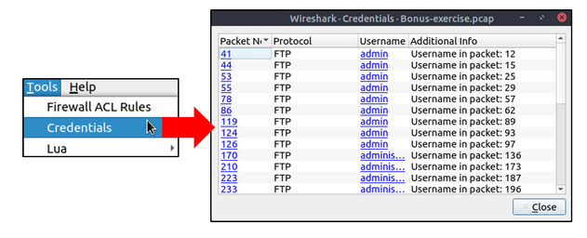

**Answer to the questions of this section-**

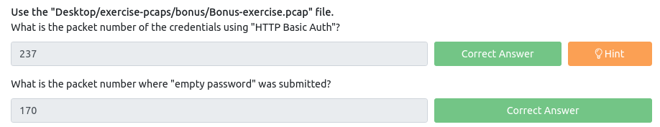

**Answers-**

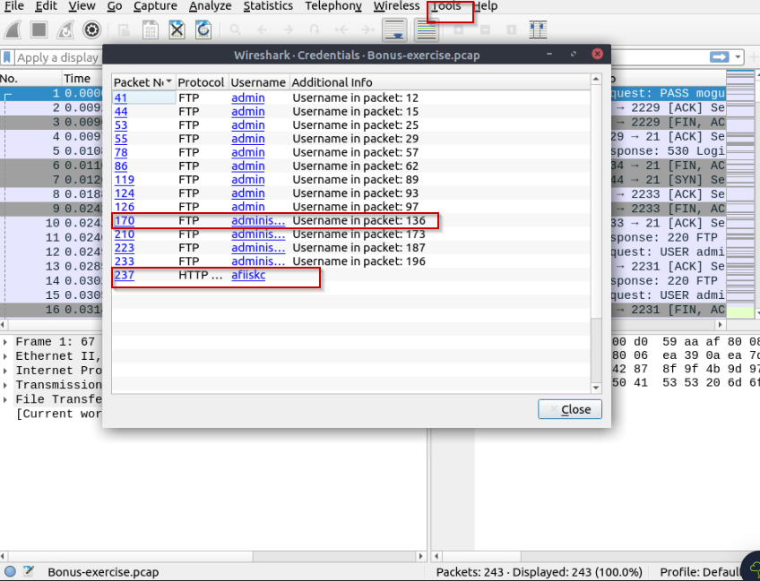

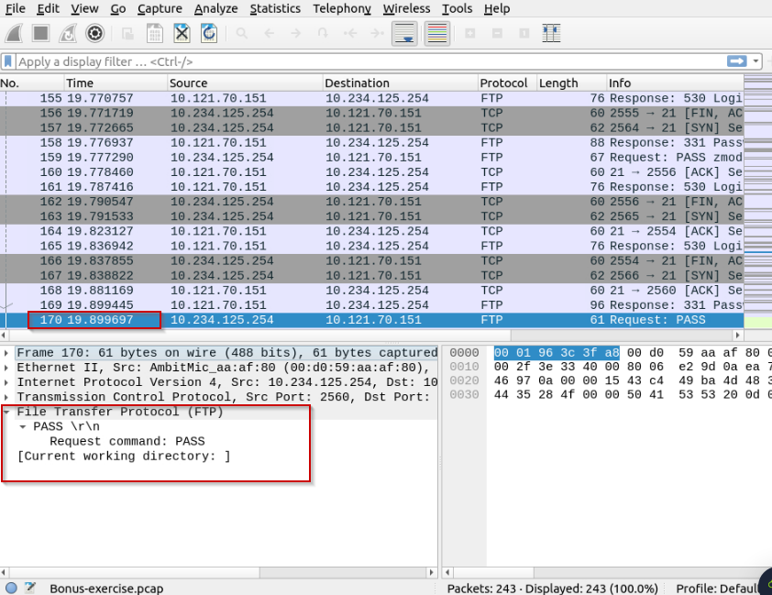

**Task 10 Bonus: Actionable Results! –**

**Bonus: Actionable Results!**

You have investigated the traffic, detected anomalies and created notes for further investigation. What is next? Not every case investigation is carried out by a crowd team. As a security analyst, there will be some cases you need to spot the anomaly, identify the source and take action. Wireshark is not all about packet details; it can help you to create firewall rules ready to implement with a couple of clicks. You can create firewall rules by using the "Tools --> Firewall ACL Rules" menu. Once you use this feature, it will open a new window and provide a combination of rules (IP, port and MAC address-based) for different purposes. Note that these rules are generated for implementation on an outside firewall interface.

Currently, Wireshark can create rules for:

* Netfilter (iptables)
* Cisco IOS (standard/extended)
* IP Filter (ipfilter)
* IPFirewall (ipfw)
* Packet filter (pf)
* Windows Firewall (netsh new/old format)

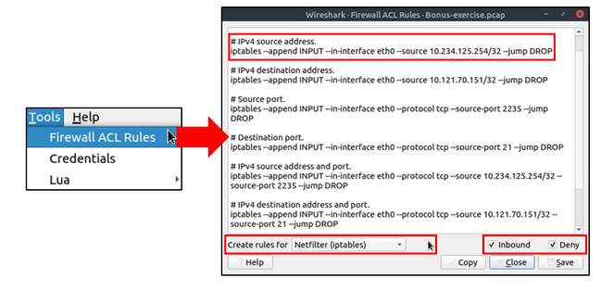

**Answer to the questions of this section-**

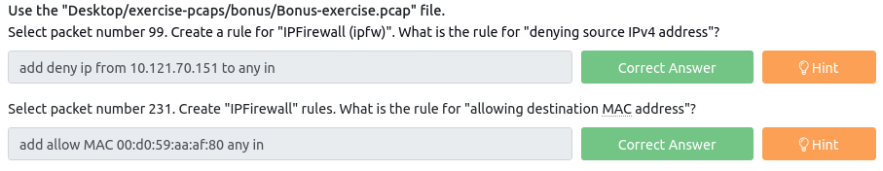

**Answers-**

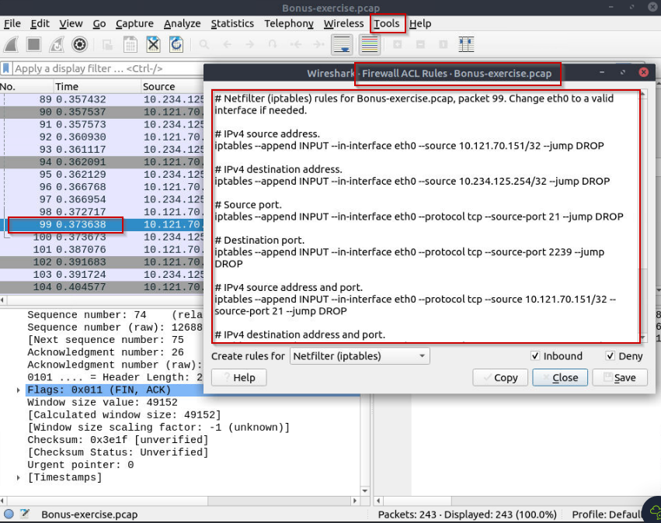

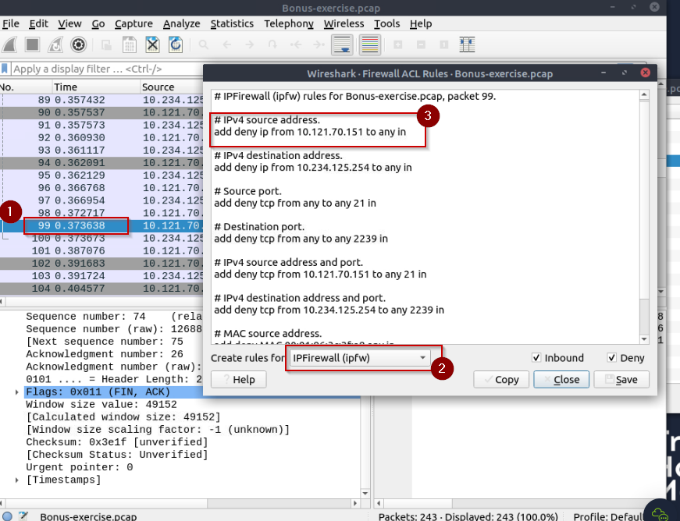

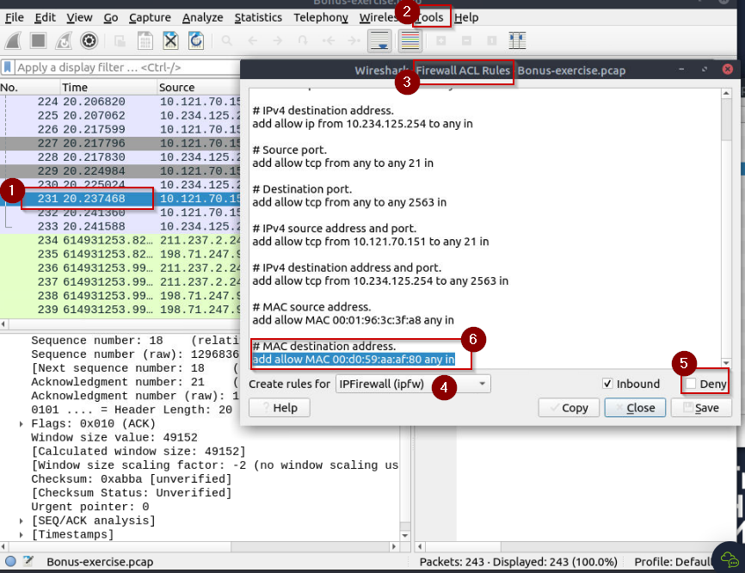

Have Fun and Enjoy Hacking! Do visit other rooms and modules on TryHackMe for more learning.

-by Shefali Kumai

For more cyber security learning follow me here-

<https://www.youtube.com/channel/UCf-F-eATCUXYaUVk8Xl7OOQ>

<https://www.instagram.com/cybersecurity.cyber_seek/>

task 5 - ssh

45 00 00 54 00 00

40 00 40 01 23 e9 0a 5f 01 01 0a 5f 01 02 08 00

5b eb 3d 08 00 01 2d 6e 13 51 2d 49 06 00 08 09

0a 0b 0c 0d 0e 0f 10 11 12 13 14 15 16 17 18 19

1a 1b 1c 1d 1e 1f 20 21 22 23 24 25 26 27 28 29

2a 2b 2c 2d 2e 2f 30 31 32 33 34 35 36 37